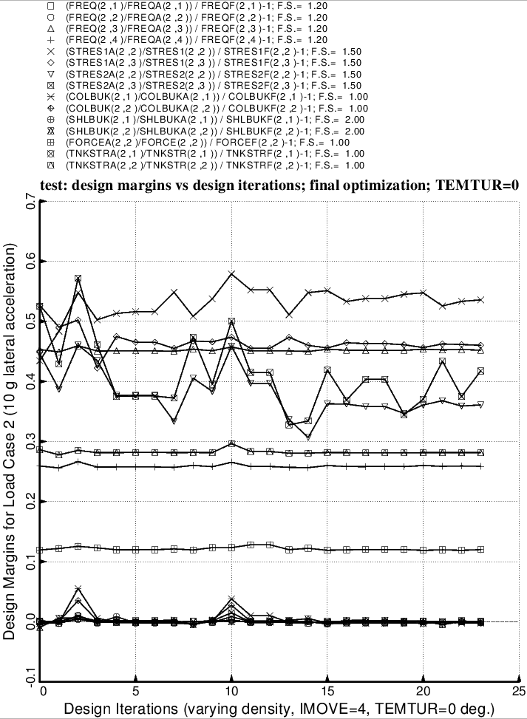

Fig. 31 (old) Load Case 2 = 10g lateral acceleration, 25 psi ullage pressure, 200 degrees propellant tank cool-down. Shown here are the most critical margins as a function of design iterations for a partial execution of the GENOPT processor, SUPEROPT. (The index, IMOVE, governs how large a change in the design is permitted by the ADS optimizer at each optimization cycle. IMOVE = 4 is quite restrictive.) Compare with the previous figure. More of the design margins are critical under Load Case 2 than under Load Case 1.

