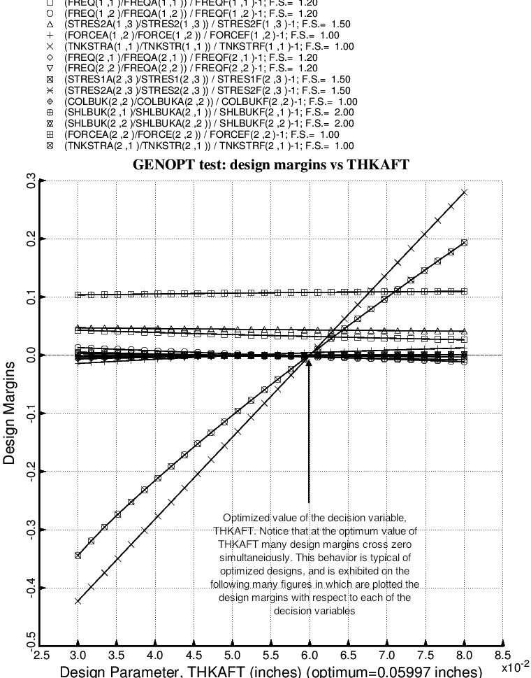

Fig. 32 (old) Design sensitivity of the optimized long propellant tank with aft and forward struts, 4 strut pairs in each set of struts. Here we have the design sensitivity with respect to the decision variable, THKAFT = uniform thickness of the middle layer of the 3-layered aft ellipsoidal dome. Design sensitivity is conducted by GENOPT whenever the End user chooses ITYPE = 3 for the analysis type during the MAINSETUP interactive session. See Table 7 for an example of typical input data for MAINSETUP when ITYPE = 3.

