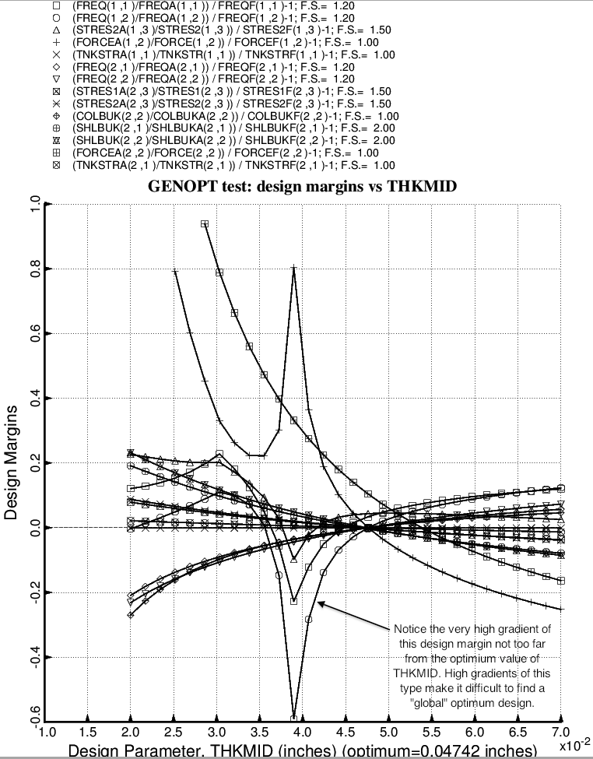

Fig. 33 (old) Design sensitivity of the optimized long propellant tank with aft and forward struts, 4 strut pairs in each set of struts. Here we have the design sensitivity with respect to the decision variable, THKMID = uniform thickness of the middle layer of the 3-layered cylindrical part of the tank.

