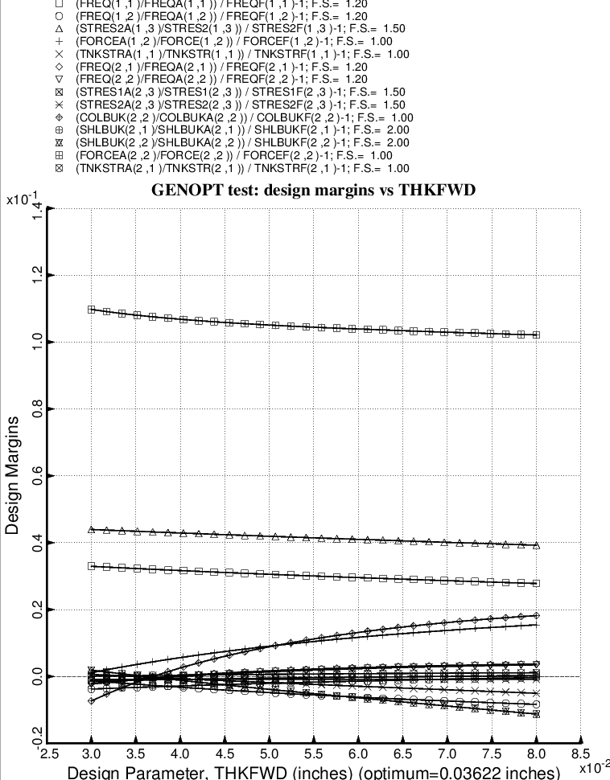

Fig. 34 (old) Design sensitivity of the optimized long propellant tank with aft and forward struts, 4 strut pairs in each set of struts. Here we have the design sensitivity with respect to the decision variable, THKFWD = uniform thickness of the middle layer of the 3-layered forward ellipsoidal dome.

