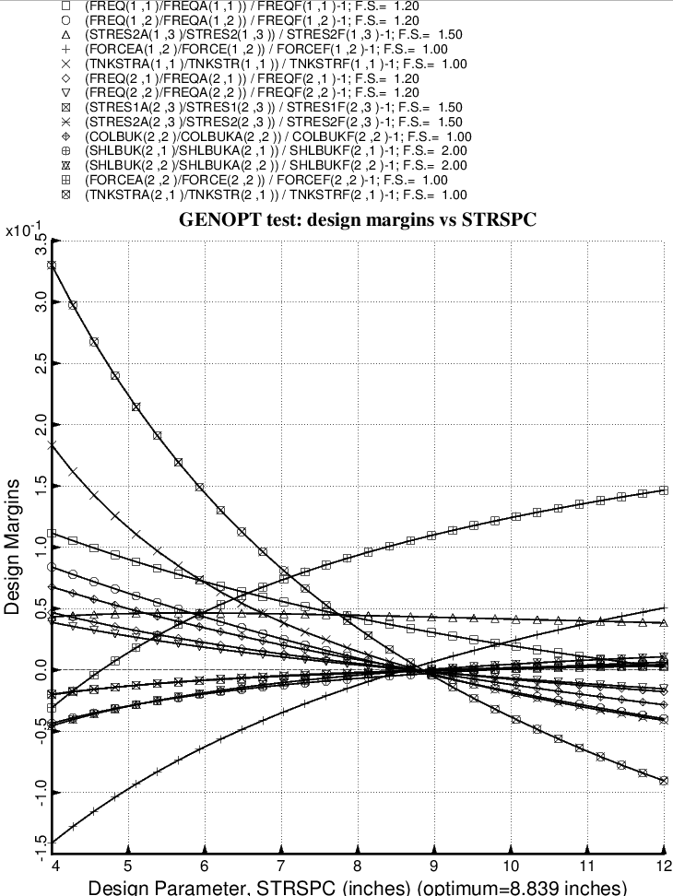

Fig. 35 (old) Design sensitivity of the optimized long propellant tank with aft and forward struts, 4 strut pairs in each set of struts. Here we have the design sensitivity with respect to the decision variable, STRSPC = uniform spacing of the stiffeners in the internal smeared orthogrid “layer” of the propellant tank.

