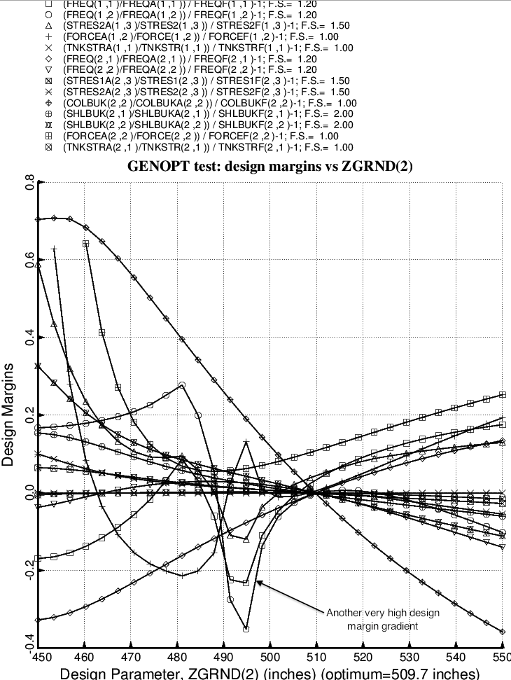

Fig. 39 (old) Design sensitivity of the optimized long propellant tank with aft and forward struts, 4 strut pairs in each set of struts. Here we have the design sensitivity with respect to the decision variable, ZGRND(2) = axial coordinate of “ground” for the forward set of struts.

