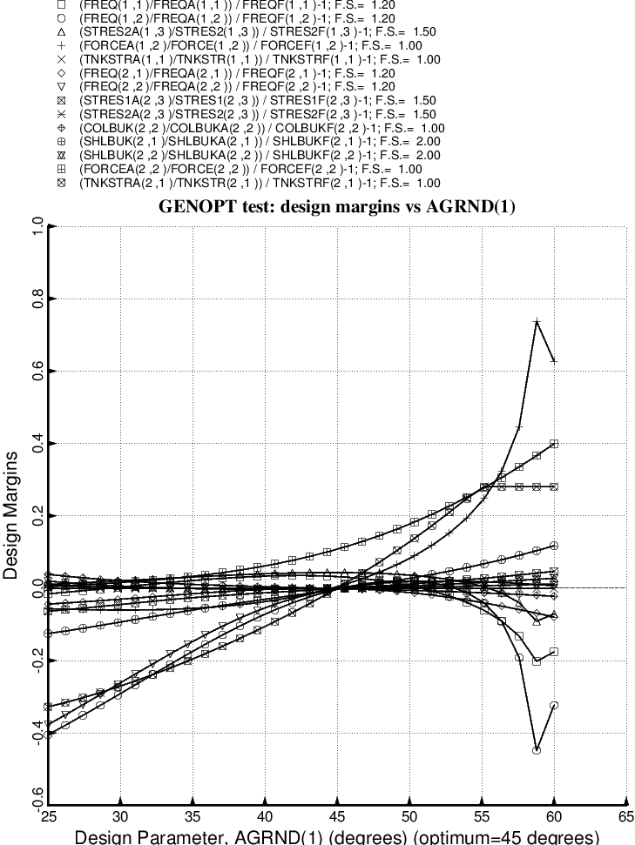

Fig. 40 (old) Design sensitivity of the optimized long propellant tank with aft and forward struts, 4 strut pairs in each set of struts. Here we have the design sensitivity with respect to the decision variable, AGRND(1) = azimuthal angle to the “ground” end of the forward-slanting struts in the aft set of struts. [The backward-slanting aft struts have –AGRND(1)]

