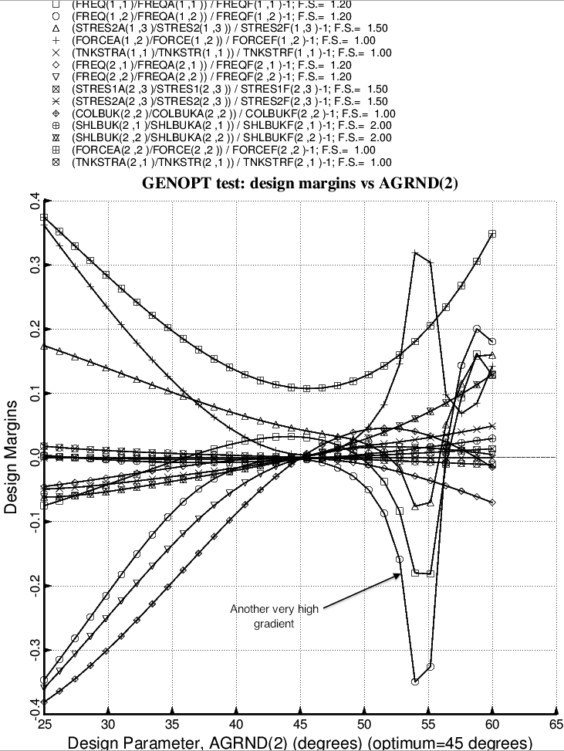

Fig. 41 (old) Design sensitivity of the optimized long propellant tank with aft and forward struts, 4 strut pairs in each set of struts. Here we have the design sensitivity with respect to the decision variable, AGRND(2) = azimuthal angle to the “ground” end of the forward-slanting struts in the forward set of struts. [The backward-slanting forward struts have –AGRND(2)]

