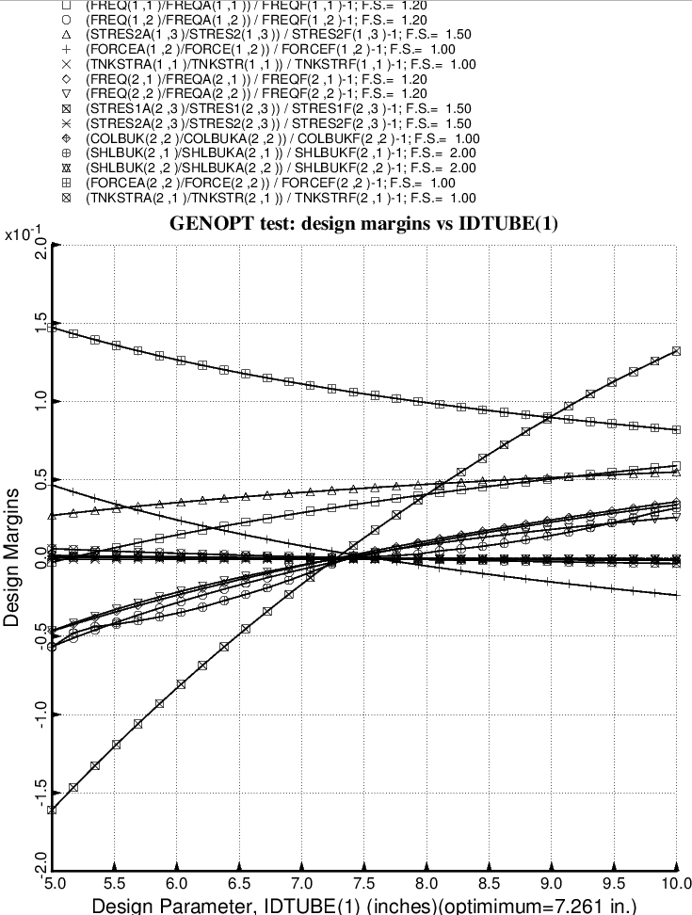

Fig. 42 (old) Design sensitivity of the optimized long propellant tank with aft and forward struts, 4 strut pairs in each set of struts. Here we have the design sensitivity with respect to the decision variable, IDTUBE(1) = inner diameter of each strut tube in the aft set of struts.

