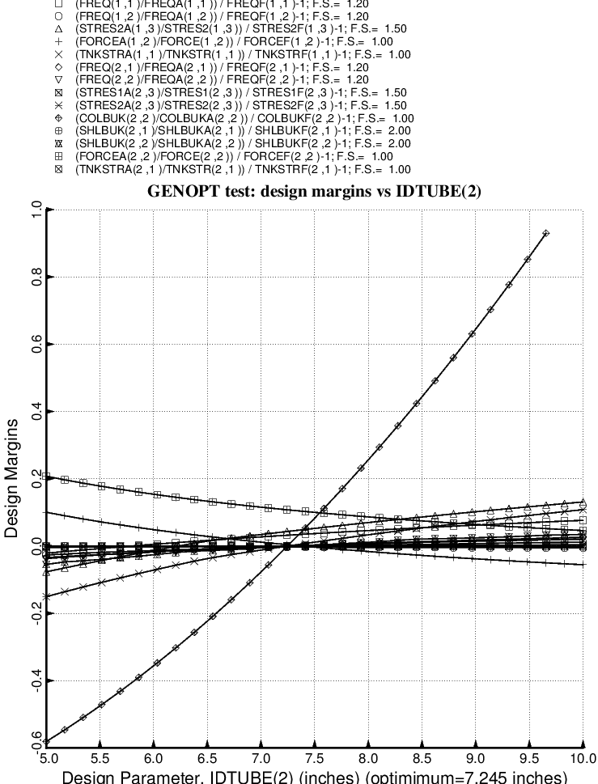

Fig. 43 (old) Design sensitivity of the optimized long propellant tank with aft and forward struts, 4 strut pairs in each set of struts. Here we have the design sensitivity with respect to the decision variable, IDTUBE(2) = inner diameter of each strut tube in the forward set of struts.

