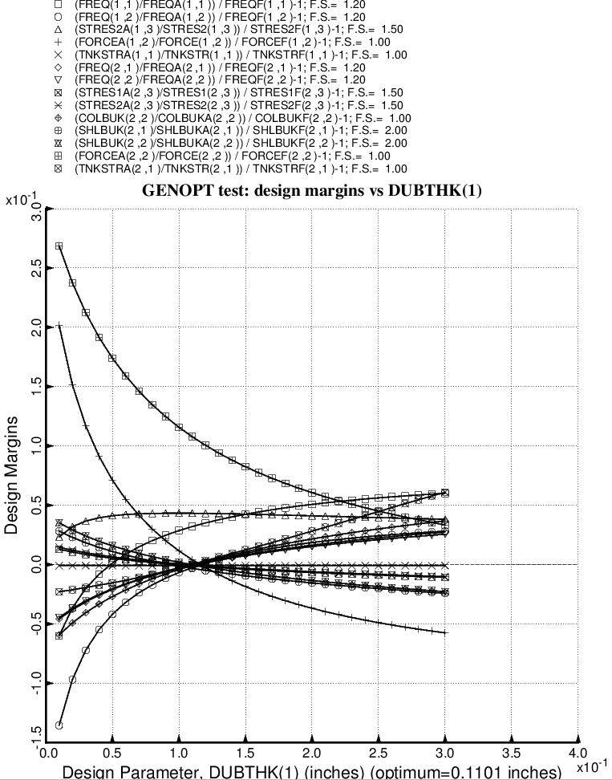

Fig. 44 (old) Design sensitivity of the optimized long propellant tank with aft and forward struts, 4 strut pairs in each set of struts. Here we have the design sensitivity with respect to the decision variable, DUBTHK(1) = maximum thickness of the external tapered doubler, which is part of the tank reinforcement type 1.

