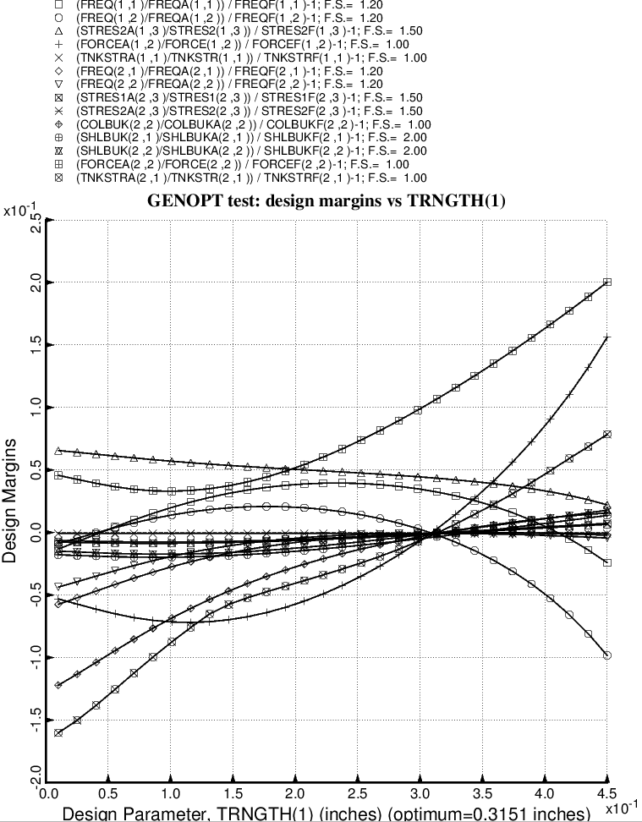

Fig. 45 (old) Design sensitivity of the optimized long propellant tank with aft and forward struts, 4 strut pairs in each set of struts. Here we have the design sensitivity with respect to the decision variable, TRNGTH(1) = thickness of the external propellant tank ring, which is part of the tank reinforcement type 1. The cross section of the ring is rectangular with ring height equal to five times the ring thickness, a linking established by the End user during the interactive session with the GENOPT processor, DECIDE. (See Table 5).

