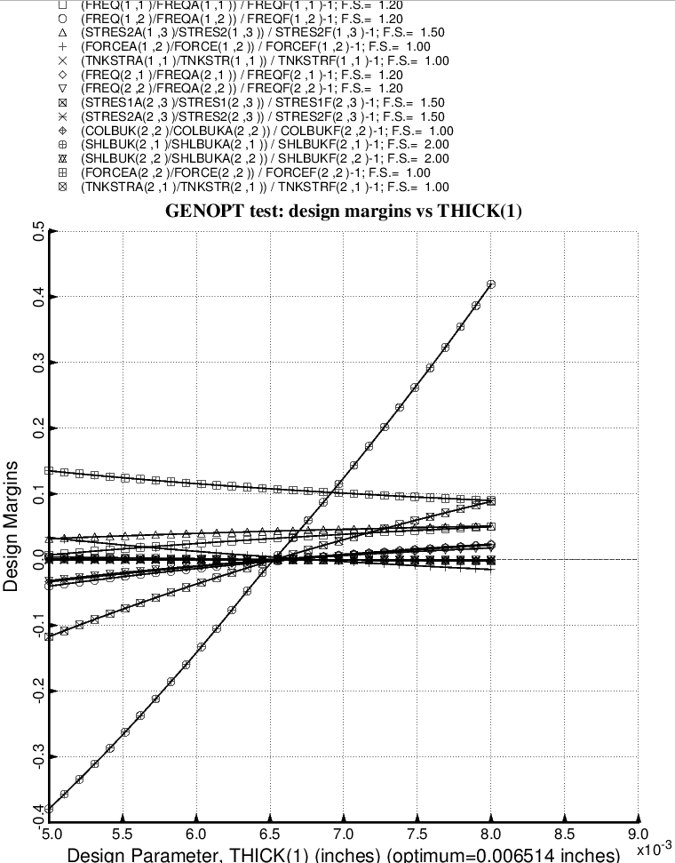

Fig. 46 (old) Design sensitivity of the optimized long propellant tank with aft and forward struts, 4 strut pairs in each set of struts. Here we have the design sensitivity with respect to the decision variable, THICK(1) = thickness of inner and outer layer of each aft laminated composite strut tube. All other layers in the aft strut tube are linked to THICK(1).

