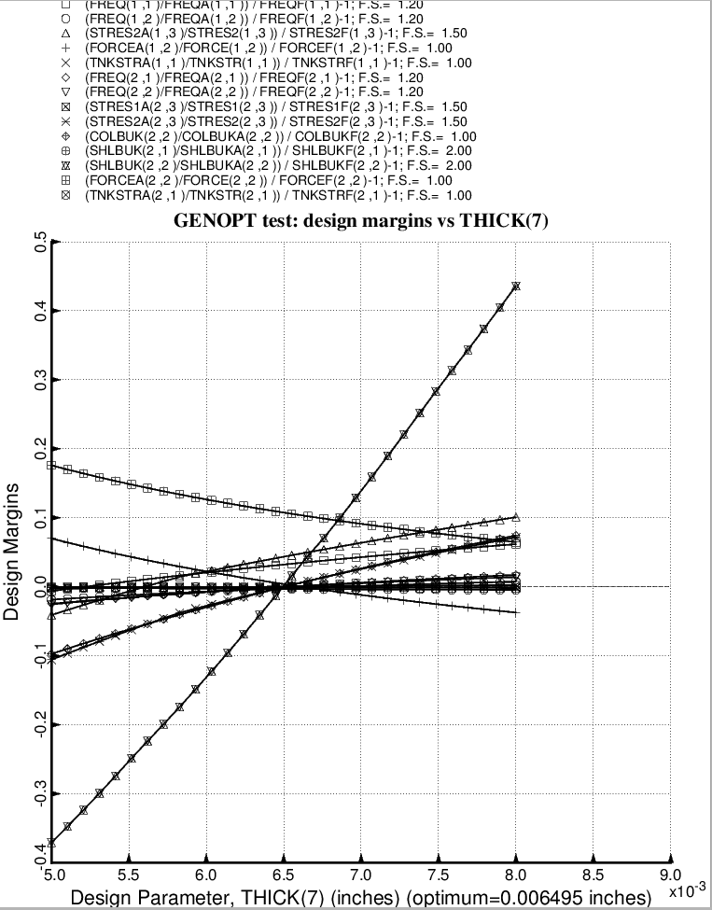

Fig. 47 (old) Design sensitivity of the optimized long propellant tank with aft and forward struts, 4 strut pairs in each set of struts. Here we have the design sensitivity with respect to the decision variable, THICK(7) = thickness of inner and outer layer of each forward laminated composite strut tube. All other layers in the forward strut tube are linked to THICK(7).

