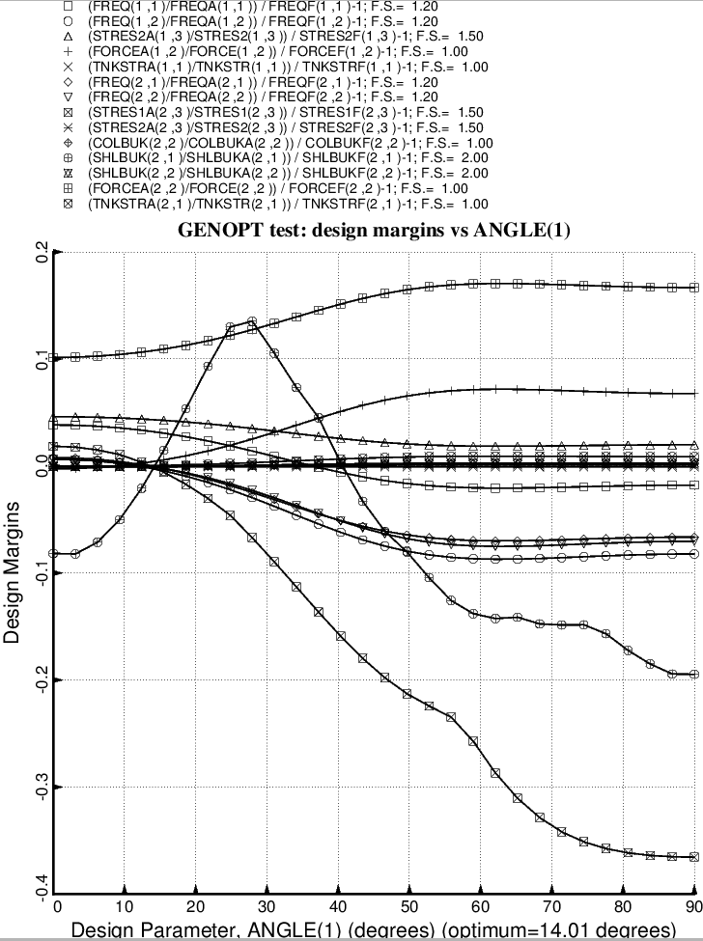

Fig. 48 (old) Design sensitivity of the optimized long propellant tank with aft and forward struts, 4 strut pairs in each set of struts. Here we have the design sensitivity with respect to the decision variable, ANGLE(1) = layup angle of the inner and outer layer of each aft laminated composite strut tube. ANGLE(2) is linked to ANGLE(1) with a linking coefficient equal to –1.0.

