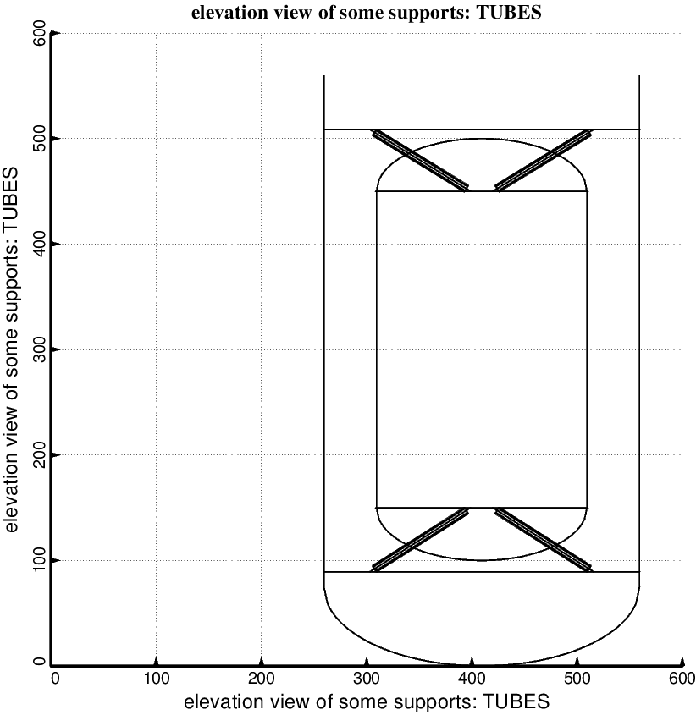

Fig. 4 (new) Optimum design of the long propellant tank with two sets of struts, aft and forward, with 4 pairs of struts in each of these two sets. Compare with the starting configuration shown in Fig. 1. (NOTE: In this elevation view only one of the four pairs of struts is displayed). This optimum design was found with use of the “temporary” (varying density) versions of bosdec (bosdec.density.var) and addbosor4 (addbosor4.density.var).

