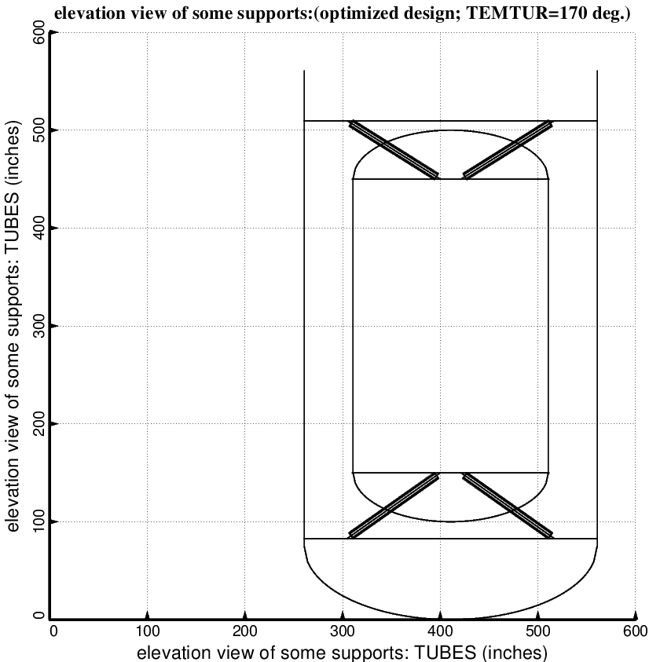

Fig. 4 (old) Optimum design of the long propellant tank with two sets of struts, aft and forward, with 4 pairs of struts in each of these two sets. Compare with the starting configuration shown in Fig. 1. (NOTE: In this elevation view only one of the four pairs of struts is displayed)

