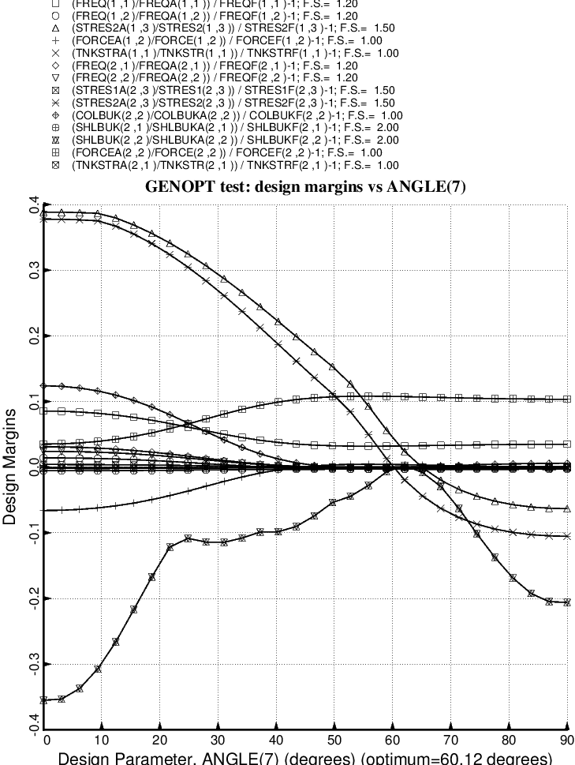

Fig. 51 (old) Design sensitivity of the optimized long propellant tank with aft and forward struts, 4 strut pairs in each set of struts. Here we have the design sensitivity with respect to the decision variable, ANGLE(7) = layup angle of the inner and outer layer of each forward laminated composite strut tube. ANGLE(8) is linked to ANGLE(7) with a linking coefficient equal to –1.0.

