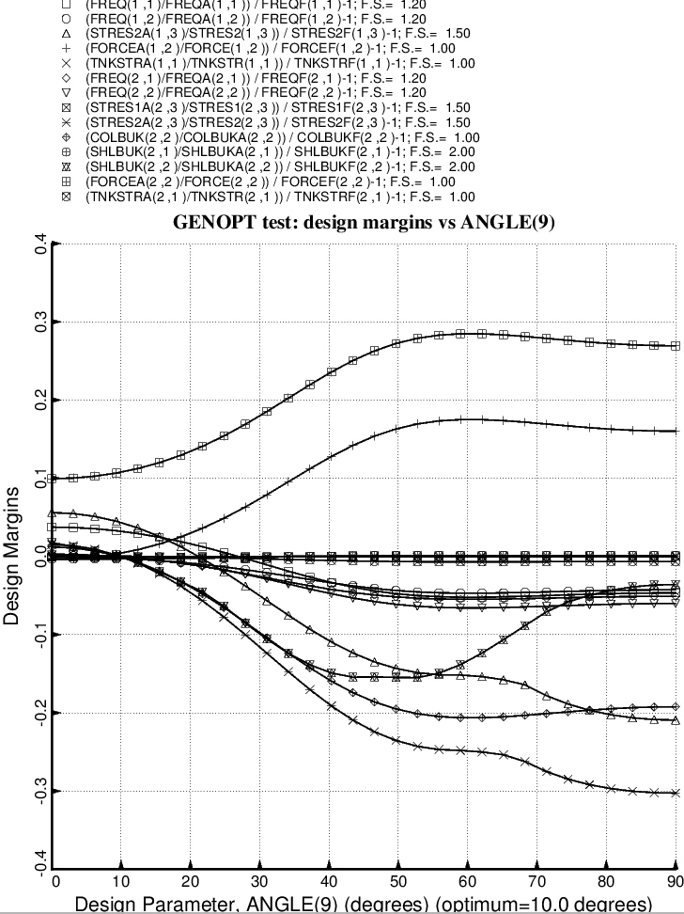

Fig. 52 (old) Design sensitivity of the optimized long propellant tank with aft and forward struts, 4 strut pairs in each set of struts. Here we have the design sensitivity with respect to the decision variable, ANGLE(9) = layup angle of the third and tenth layer of each forward laminated composite strut tube. ANGLE(10) is linked to ANGLE(9) with a linking coefficient equal to –1.0.

