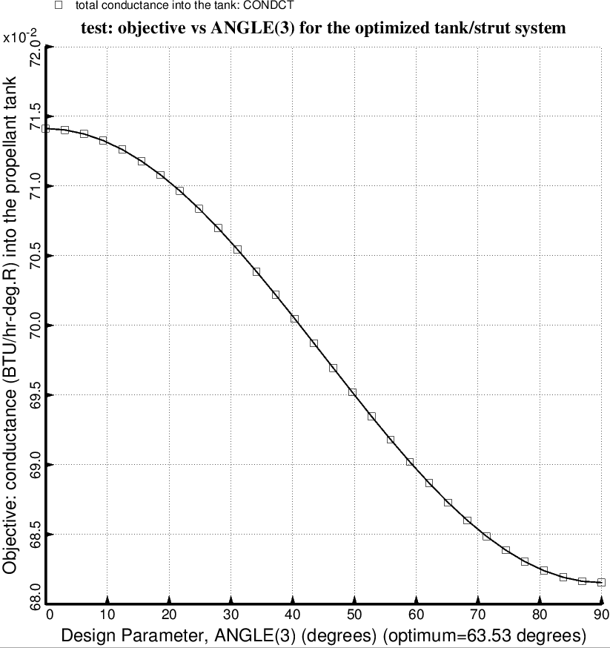
Fig. 54 (old) Design sensitivity of the optimized long propellant tank with aft and forward struts, 4 strut pairs in each set of struts. Here we have the design sensitivity of the objective = WGT x TOTMAS/TNKNRM + (1-WGT) x CONDCT/CONNRM with respect to the decision variable, ANGLE(3) = layup angle of the third and tenth layer of each aft laminated composite strut tube. NOTE: the vertical axis is mis-labeled in this figure. The label should be: objective = WGTxTOTMAS/TNKNRM + (1-WGT)xCONDCT/CONNRM. Also, the legend is mis-labeled. It should be: objective = WGTxTOTMAS/TNKNRM + (1-WGT)xCONDCT/CONNRM.

