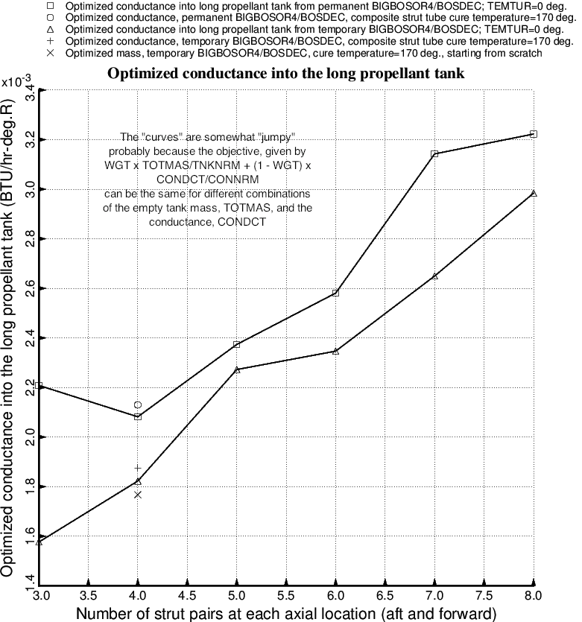

Fig. 55 (old) Optimized conductance into the long propellant tank with aft and forward sets of struts as functions of the number of strut pairs at each axial location.

