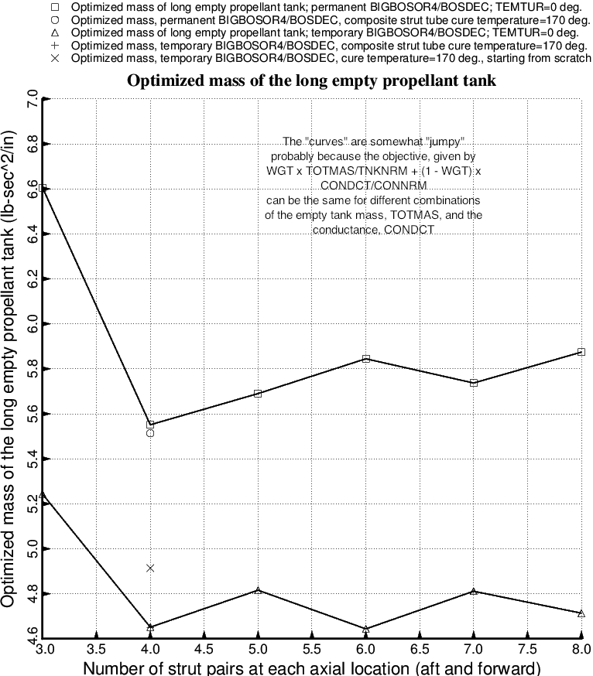

Fig. 56 (old) Optimized empty tank mass of the long propellant tank with aft and forward sets of struts as functions of the number of strut pairs at each axial location.

