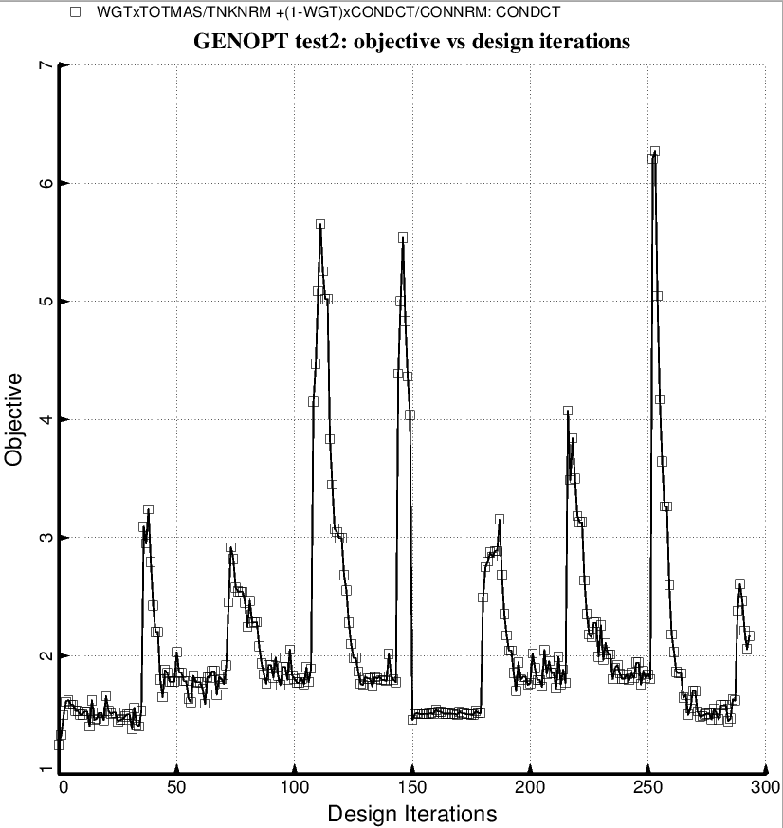

Fig. 58 (new) “Permanent” BIGBOSOR4/BOSDEC: Evolution of the objective during a partial execution of the GENOPT processor, SUPEROPT, for the short tank/strut system with only one set of struts attached to the propellant tank at the midlength of the short cylindrical part of the tank. Notice that during the long SUPEROPT process the objective converges to more than one local minimum and the objective is very “zig-zagy” from iteration to iteration. These behaviors make it difficult to find a “global” optimum design. Compare with Fig. 57, which pertains to optimization with use of the “temporary” version of BIGBOSOR4/BOSDEC.

