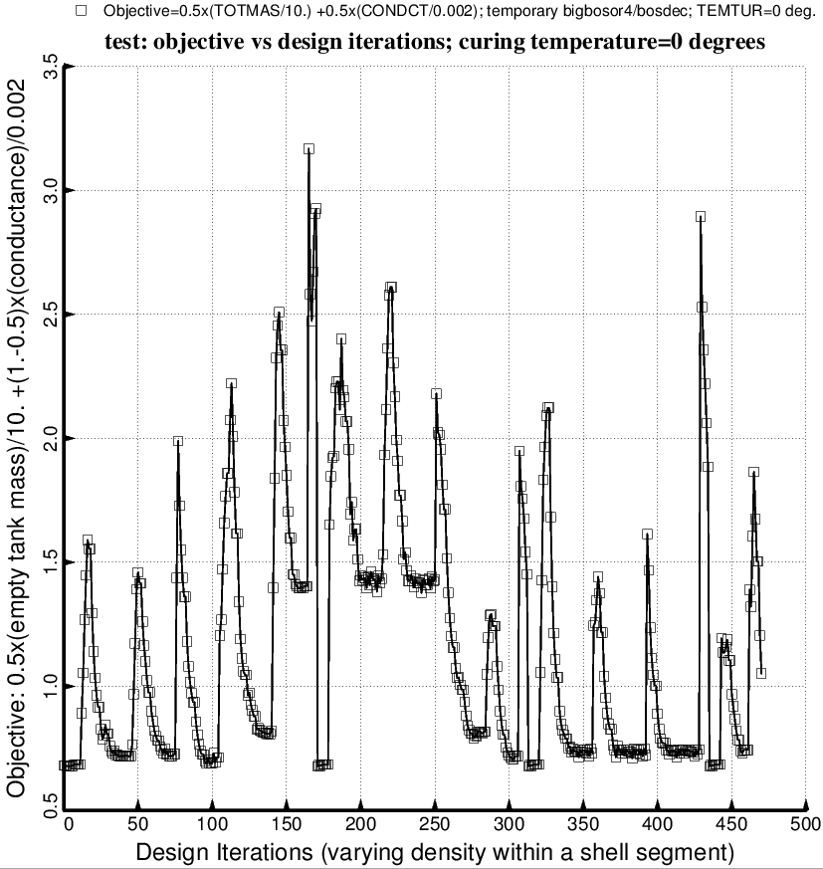

Fig. 59a (old) “Temporary” BIGBOSOR4/BOSDEC: Evolution of the objective during the second execution of the GENOPT processor, SUPEROPT, for the long tank/strut system with aft and forward sets of struts attached to the propellant tank at the dome/cylinder junctions of the tank. Notice that during the long SUPEROPT process (about 24 hours of computer time on the writer’s very fast computer) the objective converges to more than one local minimum. This behavior makes it difficult to find a “global” optimum design. Compare with the next figure, which was generated with strut tube layup angles, ANGLE(5) and ANGLE(11), fixed at 10 degrees.

