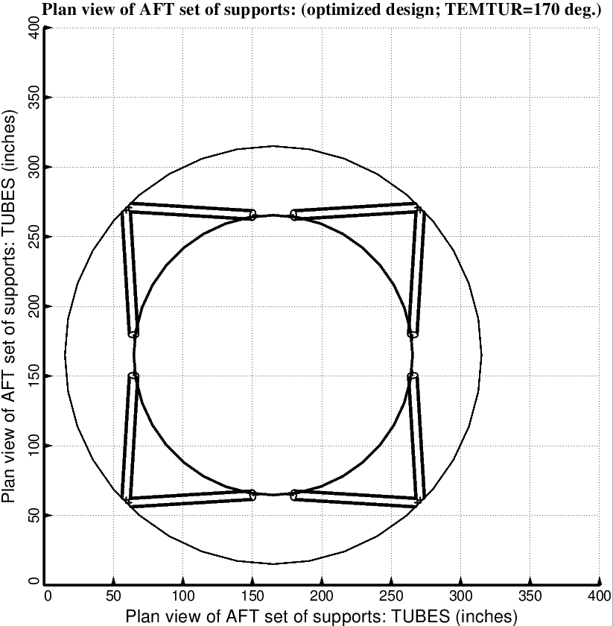

Fig. 5 (old) Optimized design of the long propellant tank with two sets of struts, aft and forward, with 4 pairs of struts in each of these two sets. Compare with the starting configuration shown in Fig. 2.

