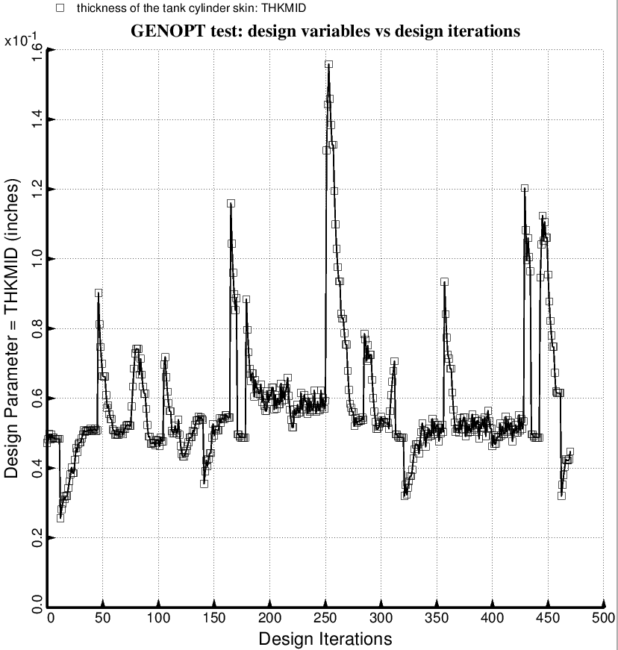

Fig. 61 (old) Temporary BIGBOSOR4/BOSDEC: Evolution of the decision variable, THKMID = uniform thickness of the middle layer of the 3-layered cylindrical part of the propellant tank, during the first SUPEROPT execution involving the long propellant tank with aft and forward sets of struts, 4 strut pairs per set. This figure corresponds to the objective plotted in Fig. 59.

