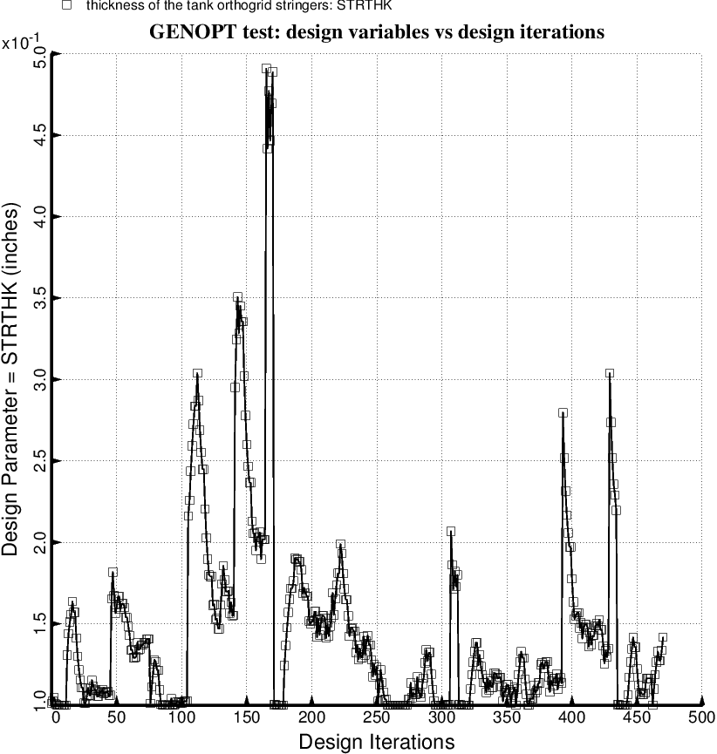

Fig. 64 (old) Temporary BIGBOSOR4/BOSDEC: Evolution of the decision variable, STRTHK = uniform thickness of the stiffeners in the internal smeared orthogrid “layer” of the propellant tank, during the first SUPEROPT execution involving the long propellant tank with aft and forward sets of struts, 4 strut pairs per set. This figure corresponds to the objective plotted in Fig. 59.

