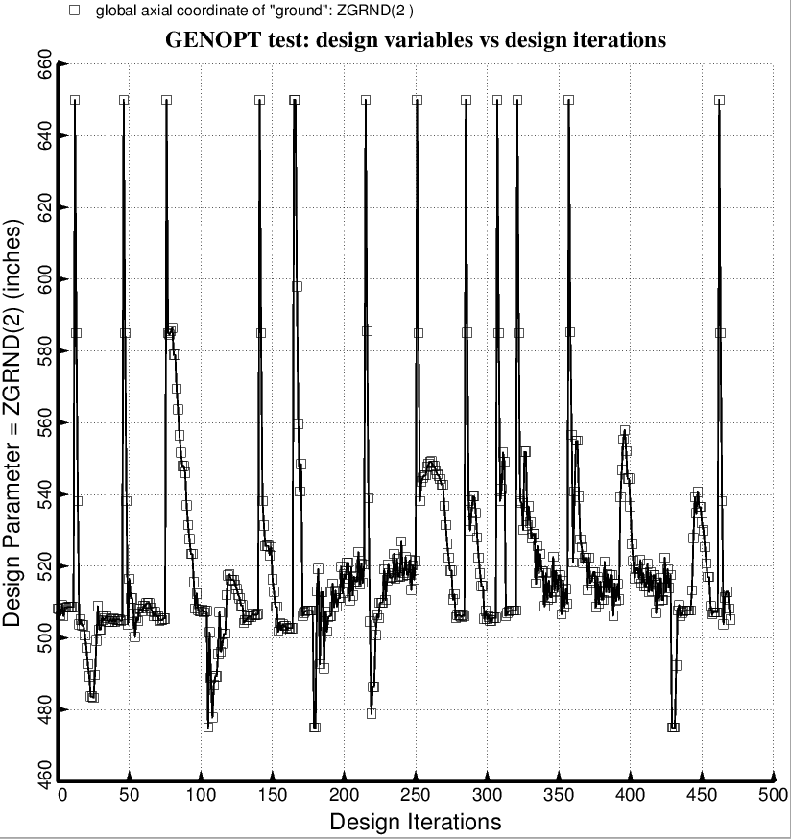

Fig. 67 (old) Temporary BIGBOSOR4/BOSDEC: Evolution of the decision variable, ZGRND(2) = axial coordinate of “ground” for the forward set of struts, during the first SUPEROPT execution involving the long propellant tank with aft and forward sets of struts, 4 strut pairs per set. This figure corresponds to the objective plotted in Fig. 59.

