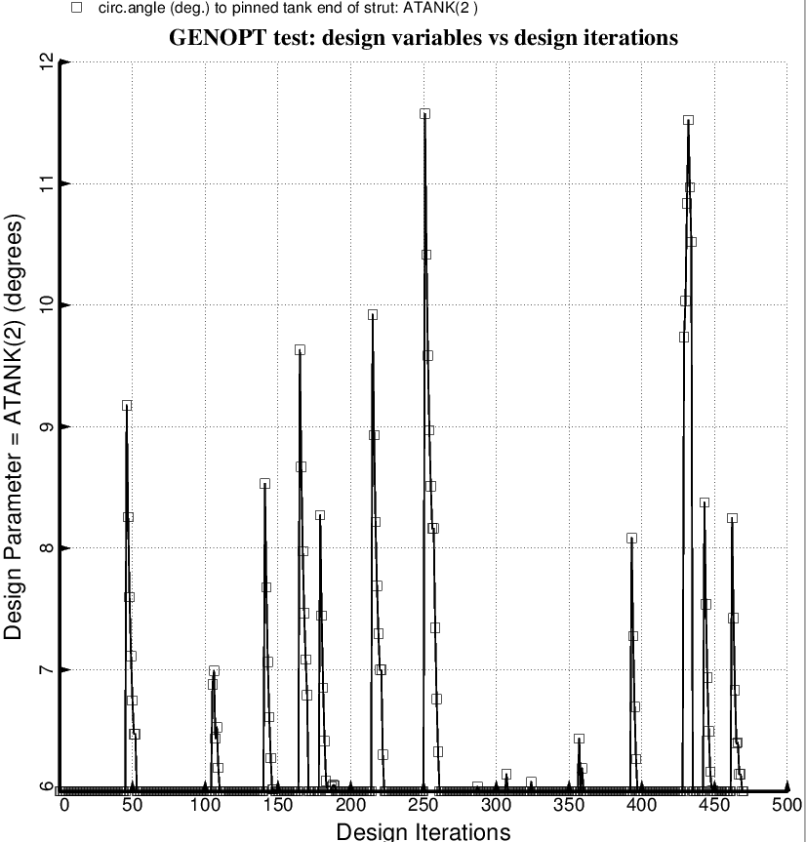

Fig. 69 (old) Temporary BIGBOSOR4/BOSDEC: Evolution of the decision variable, ATANK(2) = azimuthal angle to the tank end of the forward-slanting struts in the forward set of struts [the backward-slanting forward struts have –ATANK(2)], during the first SUPEROPT execution involving the long propellant tank with aft and forward sets of struts, 4 strut pairs per set. This figure corresponds to the objective plotted in Fig. 59.

