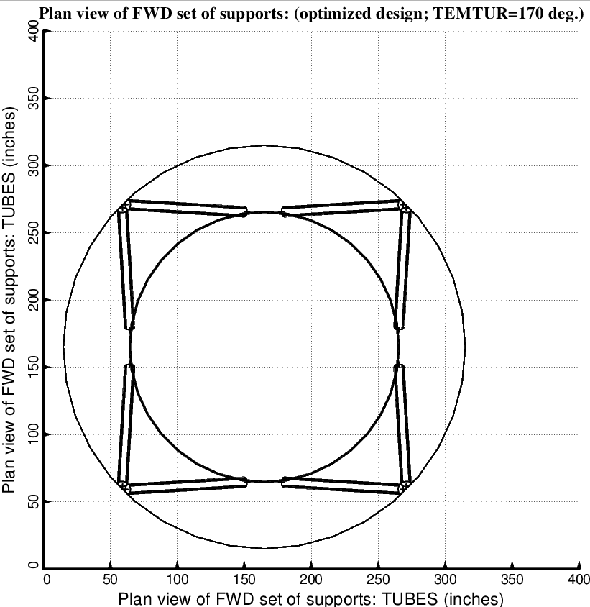

Fig. 6 (old) Optimized design of the long propellant tank with two sets of struts, aft and forward, with 4 pairs of struts in each of these two sets. Compare with the optimized configuration shown in Fig. 3.

