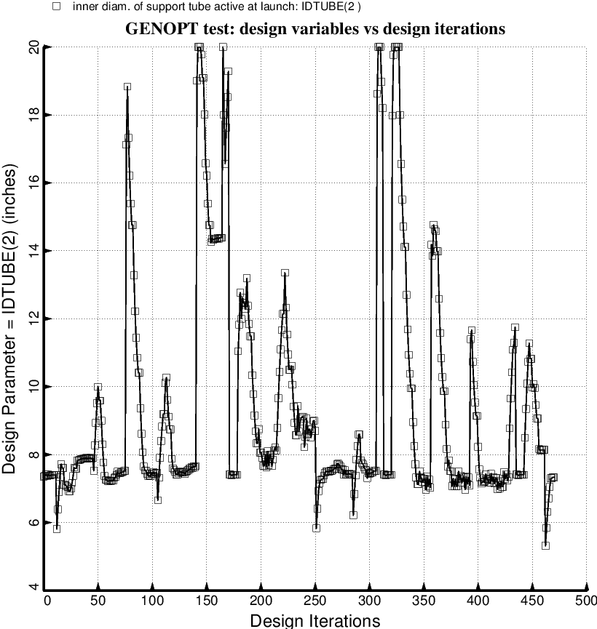

Fig. 73 (old) Temporary BIGBOSOR4/BOSDEC: Evolution of the decision variable, IDTUBE(2) = inner diameter of each forward strut tube, during the first SUPEROPT execution involving the long propellant tank with aft and forward sets of struts, 4 strut pairs per set. This figure corresponds to the objective plotted in Fig. 59.

