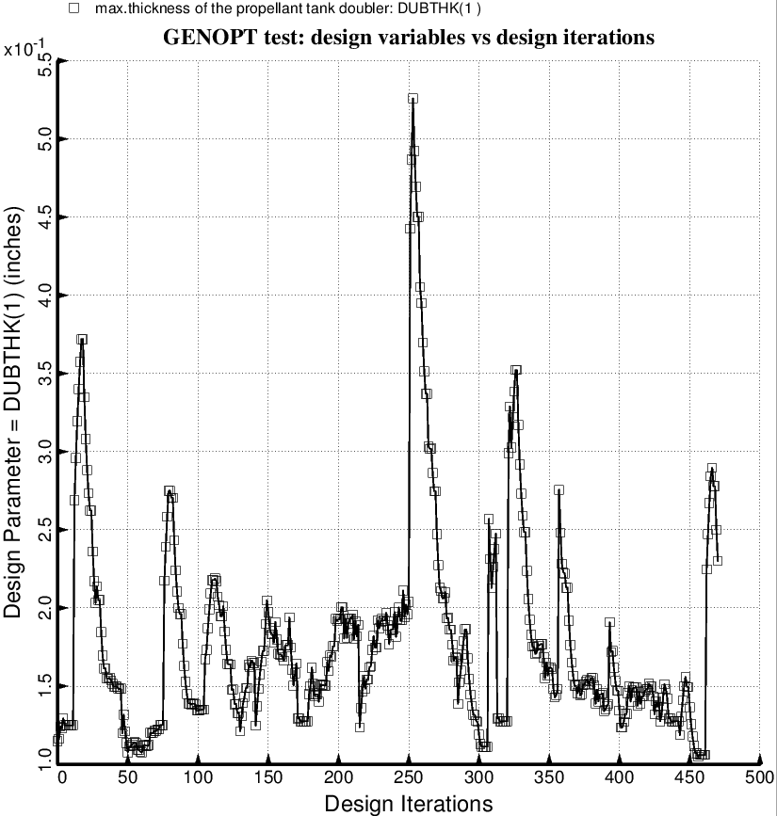

Fig. 74 (old) Temporary BIGBOSOR4/BOSDEC: Evolution of the decision variable, DUBTHK(1) = maximum thickness of the external tapered doubler, which is part of the tank reinforcement type 1, during the first SUPEROPT execution involving the long propellant tank with aft and forward sets of struts, 4 strut pairs per set. This figure corresponds to the objective plotted in Fig. 59.

