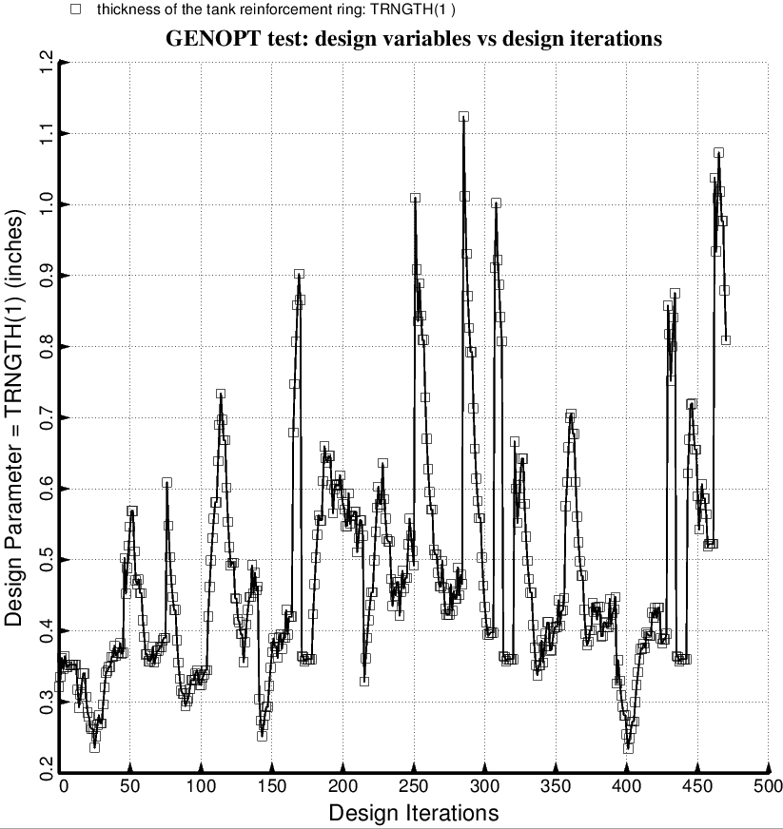

Fig. 75 (old) Temporary BIGBOSOR4/BOSDEC: Evolution of the decision variable, TRNGTH(1) = thickness of the external propellant tank ring, which is part of the tank reinforcement type 1. during the first SUPEROPT execution involving the long propellant tank with aft and forward sets of struts, 4 strut pairs per set. This figure corresponds to the objective plotted in Fig. 59. The cross section of the propellant tank support ring is rectangular with ring height equal to five times the ring thickness, a linking established by the End user during the interactive session with the GENOPT processor, DECIDE. (See Table 5).

