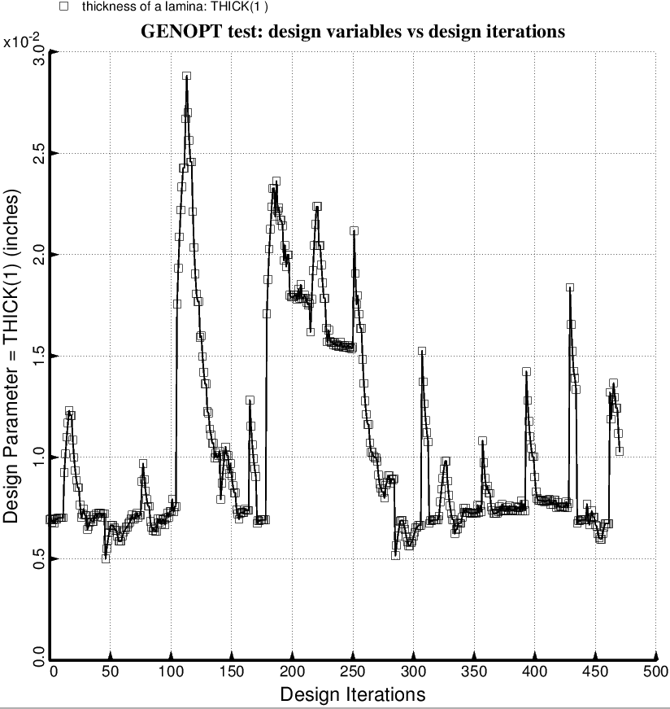

Fig. 76 (old) Temporary BIGBOSOR4/BOSDEC: Evolution of the decision variable, THICK(1) = thickness of inner and outer layer of each aft laminated composite strut tube, during the first SUPEROPT execution involving the long propellant tank with aft and forward sets of struts, 4 strut pairs per set. This figure corresponds to the objective plotted in Fig. 59. All other layers in the aft strut tube are linked to THICK(1).

