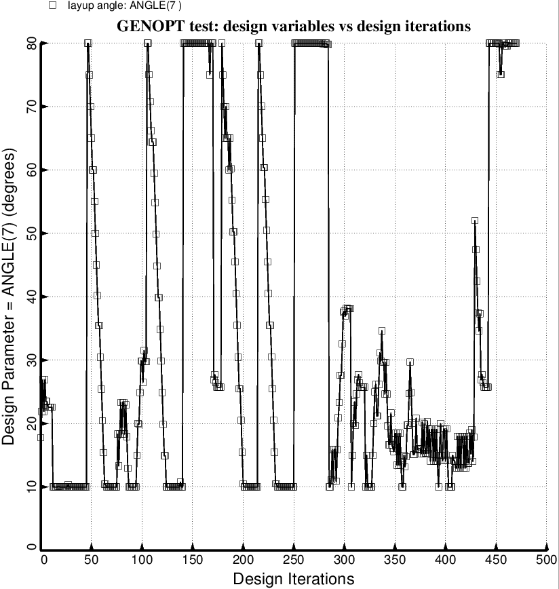

Fig. 81 (old) Temporary BIGBOSOR4/BOSDEC: Evolution of the decision variable, ANGLE(7) = layup angle of inner and outer layer of each forward laminated composite strut tube, during the first SUPEROPT execution involving the long propellant tank with aft and forward sets of struts, 4 strut pairs per set. This figure corresponds to the objective plotted in Fig. 59. ANGLE(8) is linked to ANGLE(7) with a linking coefficient equal to –1.0.

