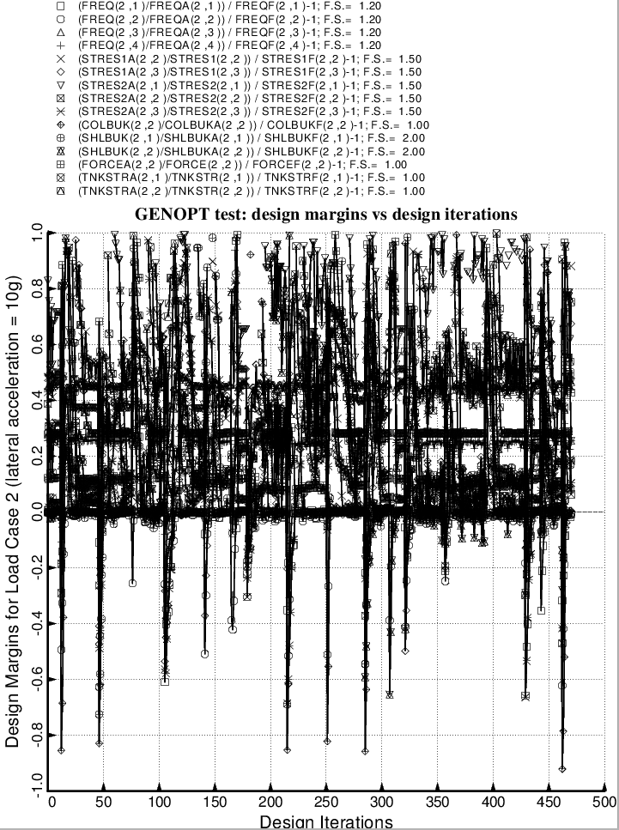

Fig. 85 (old) Temporary BIGBOSOR4/BOSDEC: Evolution of the most critical design margins for Load Case 2 (10g lateral acceleration, 25 psi ullage pressure, 200 degree tank cool-down), during the first SUPEROPT execution involving the long propellant tank with aft and forward sets of struts, 4 strut pairs per set. This figure corresponds to the objective plotted in Fig. 59.

