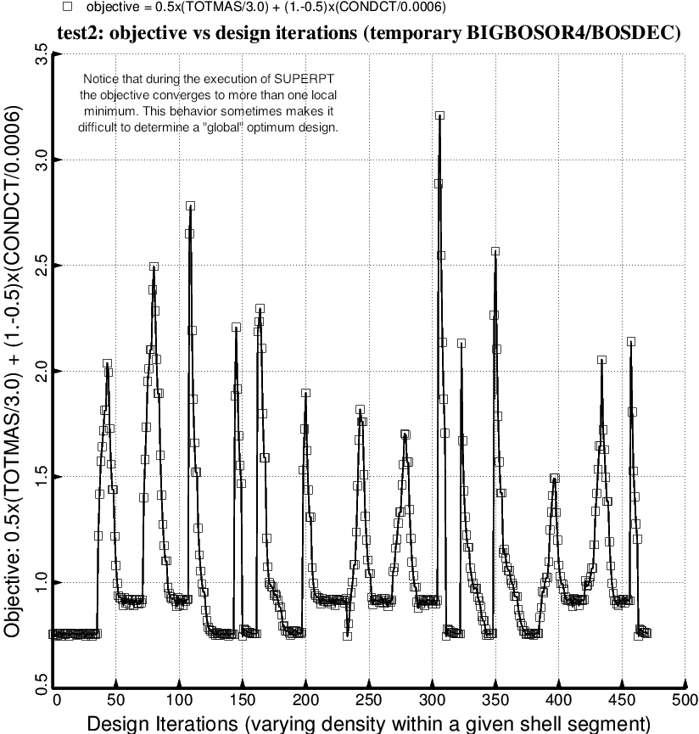

Fig. 86 (old) “Temporary” BIGBOSOR4/BOSDEC: Evolution of the objective during the second execution of the GENOPT processor, SUPEROPT, for the short tank/strut system with only one set of struts attached to the propellant tank at the midlength of the short cylindrical part of the tank. Notice that during the long SUPEROPT process (about 15 hours of computer time on the writer’s very fast computer) the objective converges to more than one local minimum. This behavior makes it difficult to find a “global” optimum design. Compare with Fig. 88, which was generated with strut tube layup angle, ANGLE(5), fixed at 10 degrees.

