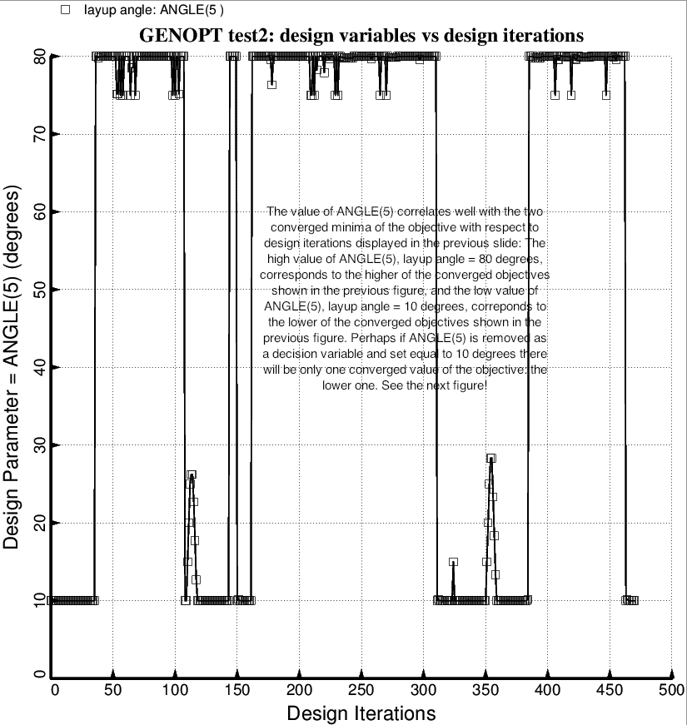

Fig. 87 (old) “Temporary” BIGBOSOR4/BOSDEC: Evolution of the strut tube layup angle, ANGLE(5) = layup angle of layers 3 and 10 of a strut tube, during the second execution of the GENOPT processor, SUPEROPT, for the short tank/strut system with only one set of struts attached to the propellant tank at the midlength of the short cylindrical part of the tank. The behavior of ANGLE(5) during this execution of SUPEROPT correlates well with the higher and lower local minima of the converged objective plotted in the previous figure. Therefore, another execution of SUPEROPT was performed, this time with ANGLE(5) fixed at 10 degrees (which corresponds to the “global” optimum design) rather than being chosen as a decision variable. The result of that SUPERPT run is plotted in the next figure.

