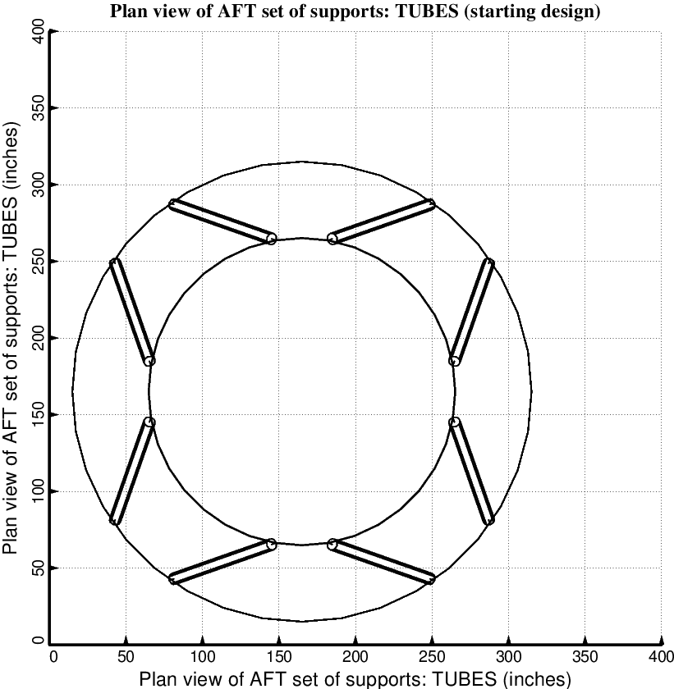

Fig. 8 (old) Starting design of the short propellant tank with one set of struts, called “aft”, with 4 pairs of struts in this one set. Compare with the optimized configuration shown in Fig. 10.

