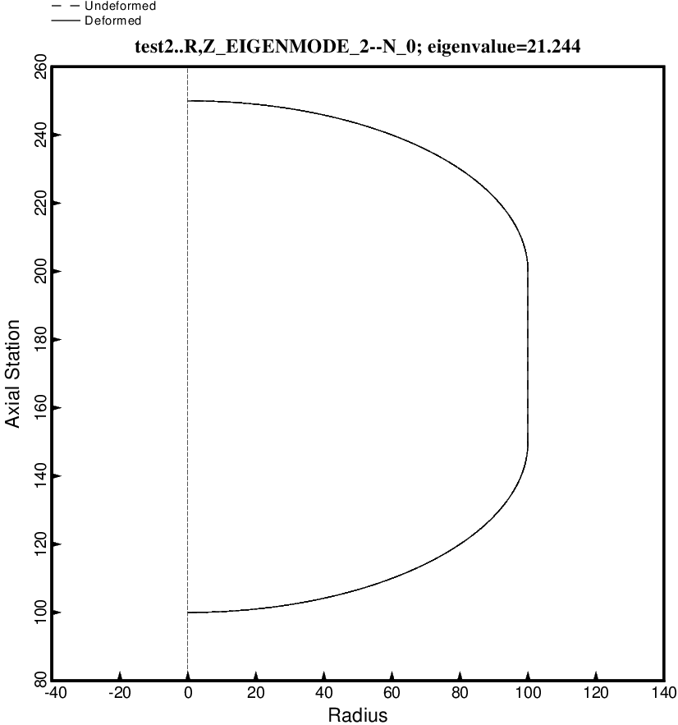

Fig. 90 (new) Free vibration mode of the optimized tank/strut system for the short propellant tank with one set of struts, 4 strut pairs in that set, Load Case 2 (test.BEHX12). The struts are attached to a propellant tank support ring located at the same axial coordinate as the midlength of the propellant tank. The struts are present in the BIGBOSOR4 model but are not plotted here because BIGBOSOR4 does not yet have the capability to plot springs. This second mode with n = 0 circumferential waves corresponds to rolling motion. The optimum design was found with use of the “permanent” (constant density) versions of bosdec (bosdec.tank) and addbosor4 (addbosor4.tank).

