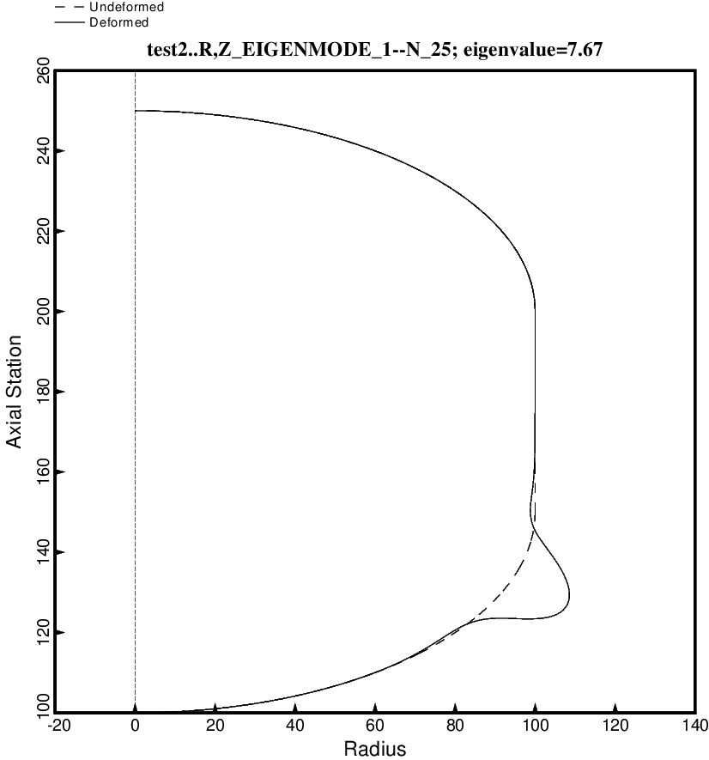

Fig. 94 (new) Buckling of the short optimized tank with one set of struts, 4 strut pairs in that set. The loading is Load Case 1: axial acceleration = 10 g, 25 psi ullage pressure, 200 deg. tank cool-down. Buckling in the aft 2:1 ellipsoidal dome is caused by the narrow band of hoop compression in the dome knuckle region. This optimum design was found with use of the “temporary” (varying density) versions of bosdec (bosdec.density.var) and addbosor4 (addbosor4.density.var). This figure is analogous to Fig. 23.

