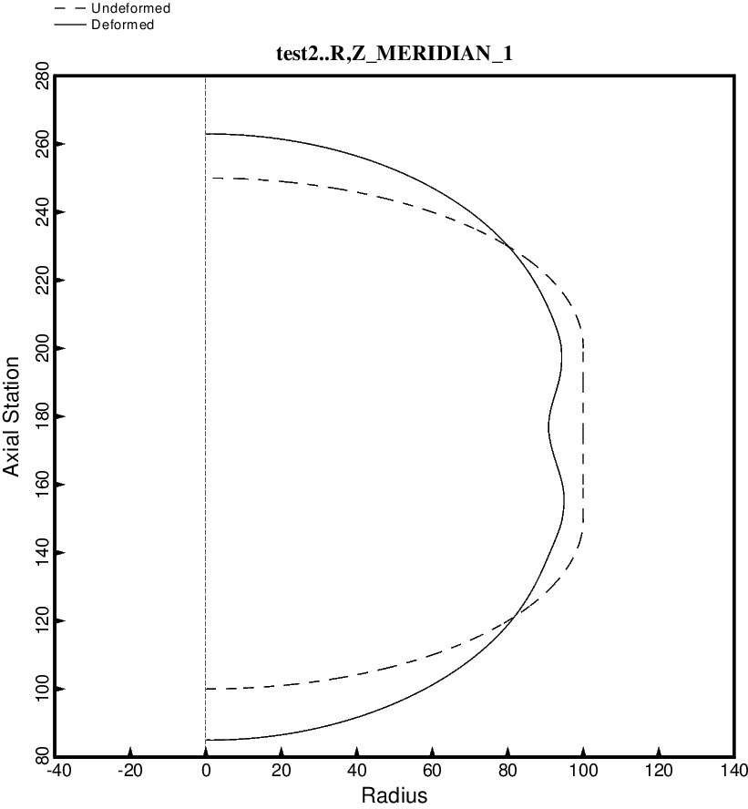

Fig. 99 (new) Load Case 2 (10 g lateral acceleration, 25 psi ullage pressure, 200 deg. tank cool-down): Deformation along the meridian at 100 degrees of the short propellant tank with one set of struts, 4 strut pairs in that set of struts. This optimum design was found with use of the “temporary” (varying density) versions of bosdec (bosdec.density.var) and addbosor4 (addbosor4.density.var). This figure is analogous to Fig. 28c.

