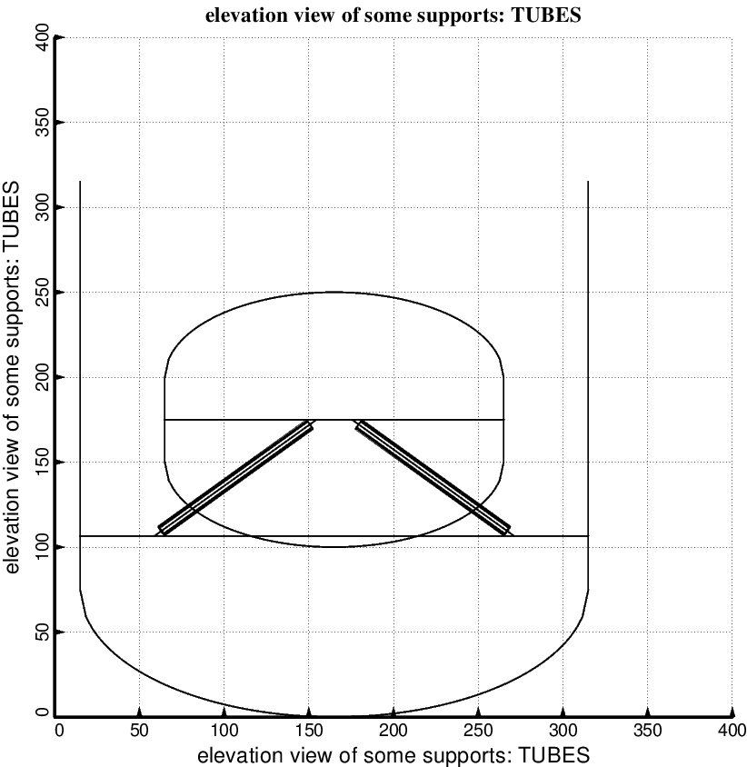

Fig. 9 (new) Optimized design of the short propellant tank with one set of struts, called “aft”, with 4 pairs of struts in this one set. Compare with the starting configuration shown in Fig. 7. (NOTE: In this elevation view only one of the four pairs of struts is displayed). This optimum design was found with use of the “temporary” (varying density) versions of bosdec (bosdec.density.var) and addbosor4 (addbosor4.density.var).

