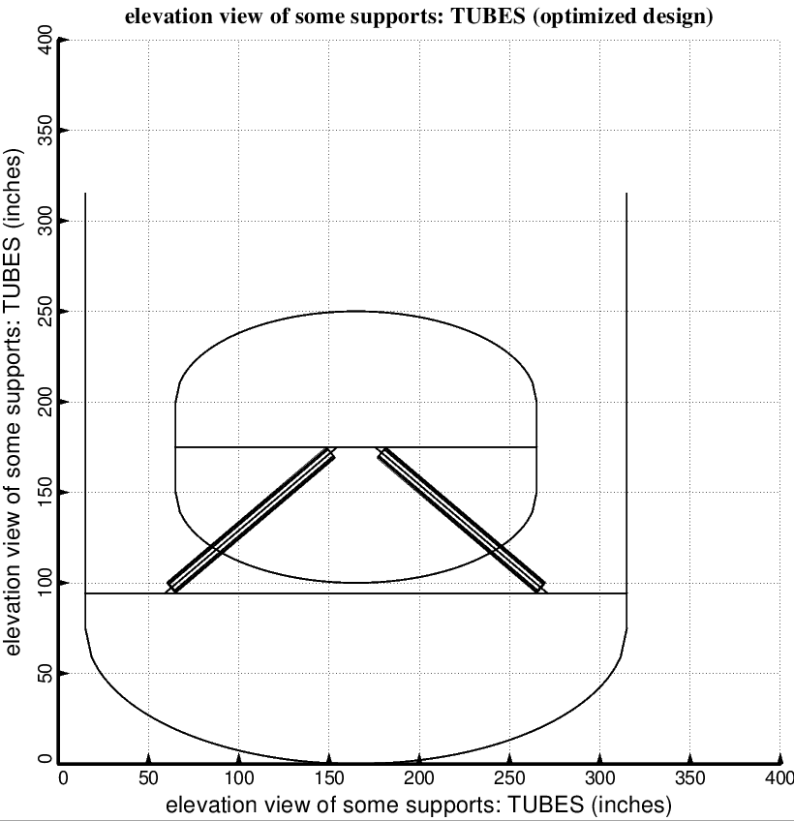

Fig. 9 (old) Optimized design of the short propellant tank with one set of struts, called “aft”, with 4 pairs of struts in this one set. Compare with the starting configuration shown in Fig. 7. (NOTE: In this elevation view only one of the four pairs of struts is displayed)

