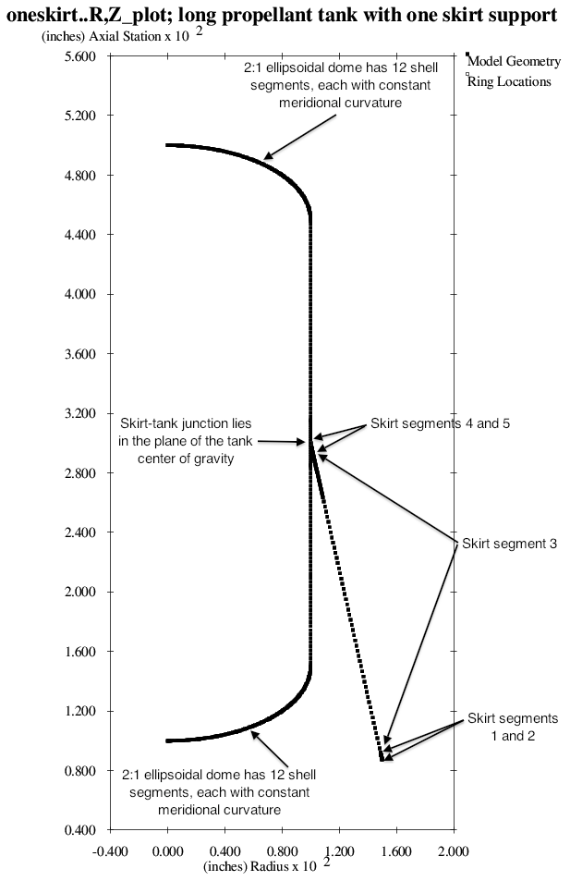

Fig. 1 Optimized discretized tank/skirt system obtained with the use of the “temporary” versions of bosdec (bosdec.tank2.density.var) and addbosor4 (addbosor4.tank2.density.var). Predictions from this optimized configuration should be compared with predictions from STAGS. The configuration and GENOPT/BIGBOSOR4 predictions are listed in Table 6. The bottom end of the skirt is simply supported to “ground” (the rigid launch vehicle).

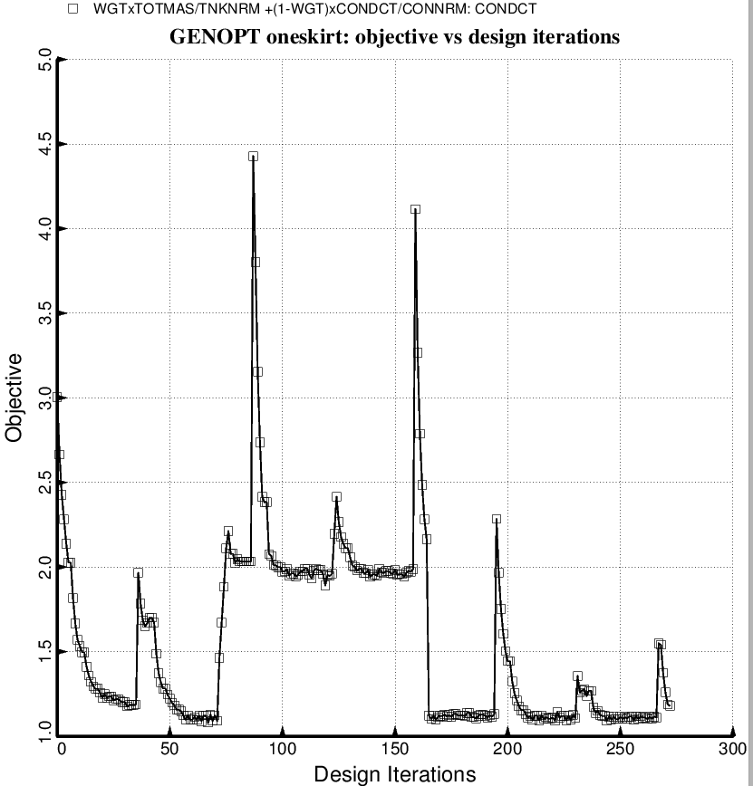

Fig. 2a (new) Evolution of the objective during a partial execution of SUPEROPT for the specific case, “oneskirt” obtained with the use of the “temporary” versions of bosdec (bosdec.tank2.density.var) and addbosor4 (addbosor4.tank2.density.var). The decision variables are listed in Table 4.

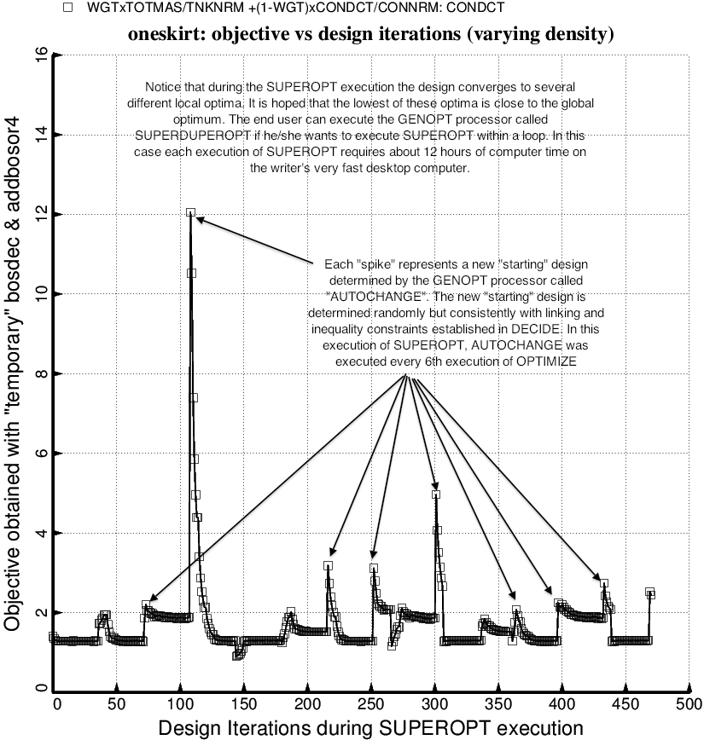

Fig. 2a (old) Evolution of the objective during an execution of SUPEROPT for the specific case, “oneskirt” obtained with the use of the “temporary” versions of bosdec and addbosor4. The decision variables are listed in Table 4.

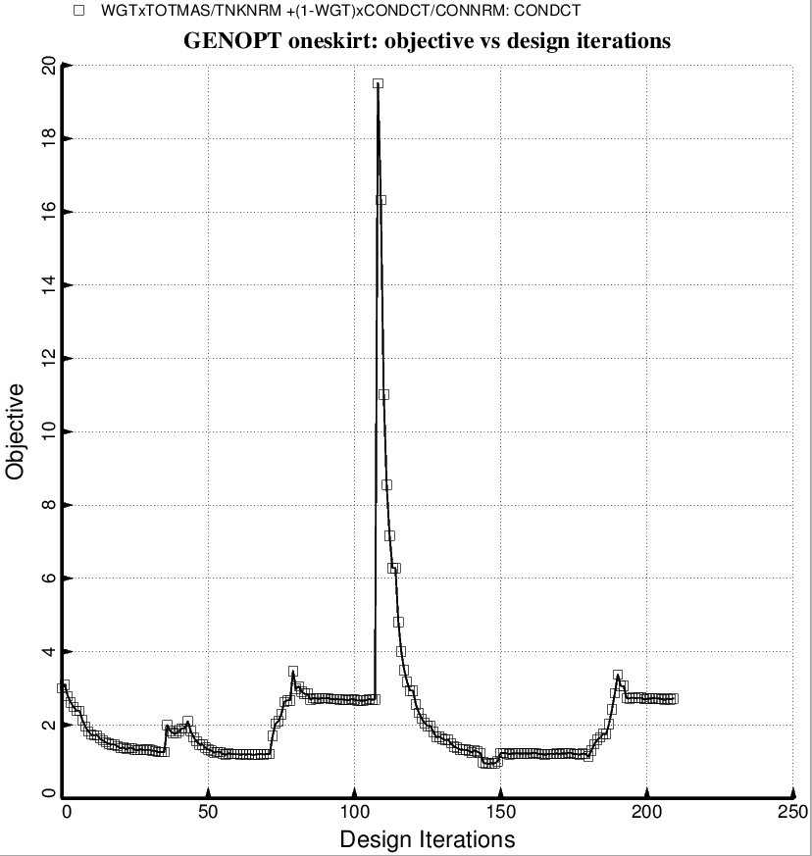

Fig. 2b (new) Evolution of the objective during a partial execution of SUPEROPT for the specific case, “oneskirt” obtained with the use of the “permanent” versions of bosdec (bosdec.tank2) and addbosor4 (addbosor4.regular). The decision variables are listed in Table 4.

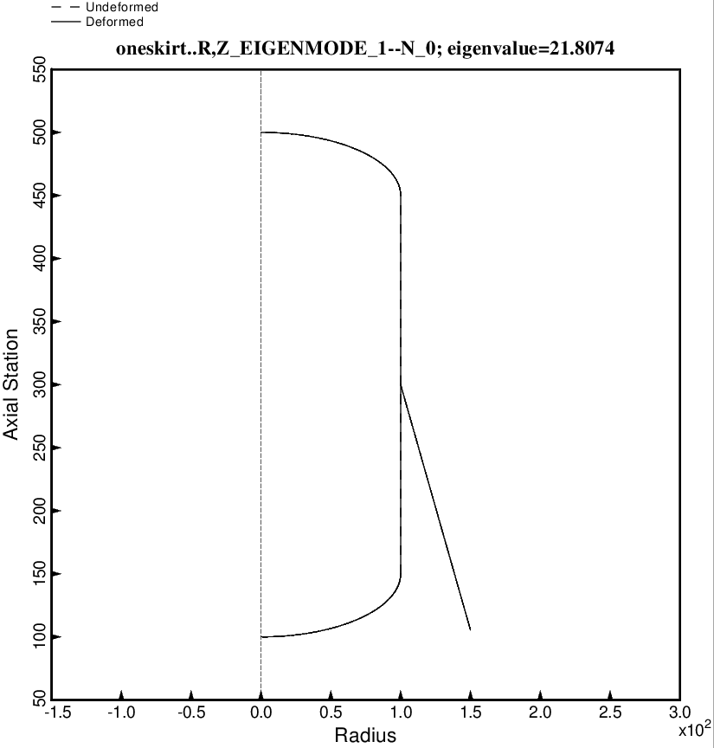

Fig. 3 (new) Rolling vibration mode for the optimized tank/skirt system determined with use of the “regular” or “permanent” versions of bosdec (bosdec.tank2) and addbosor4 (addbosor4.regular).

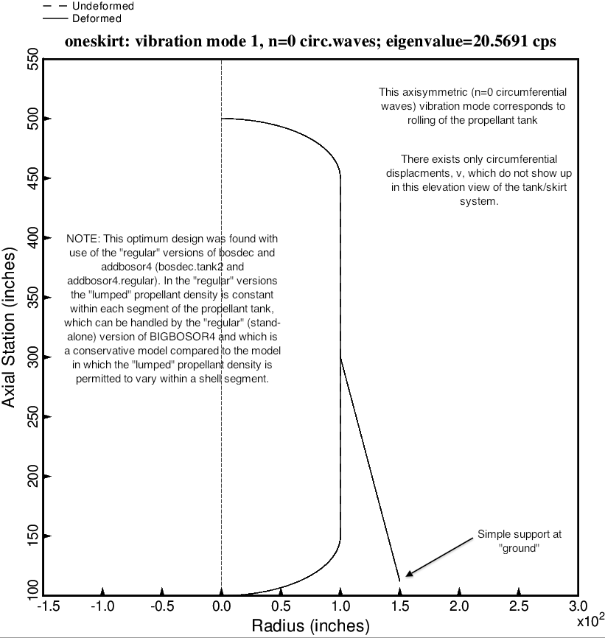

Fig. 3 (old) Rolling vibration mode for the optimized tank/skirt system determined with use of the “regular” or “permanent” versions of bosdec (bosdec.tank2) and addbosor4 (addbosor4.regular).

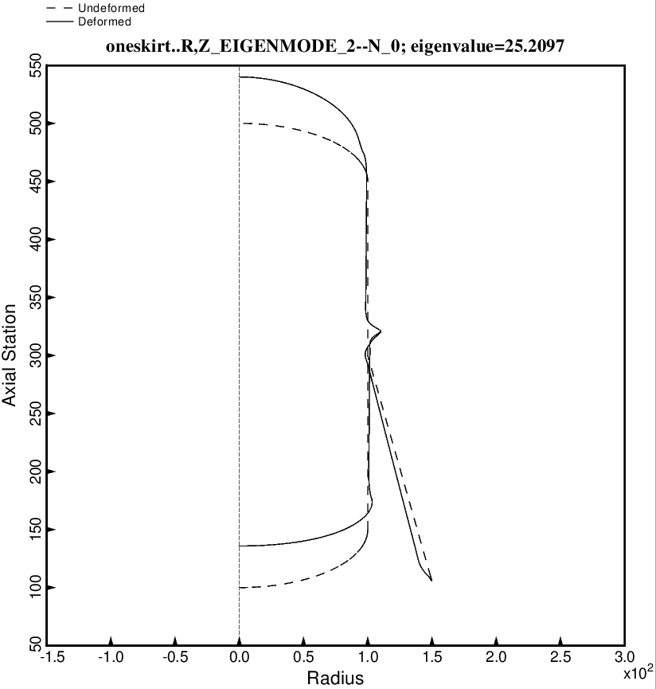

Fig. 4 (new) Axisymmetric axial vibration mode for the optimized tank/skirt system determined with use of the “regular” or “permanent” versions of bosdec (bosdec.tank2) and addbosor4 (addbosor4.regular).

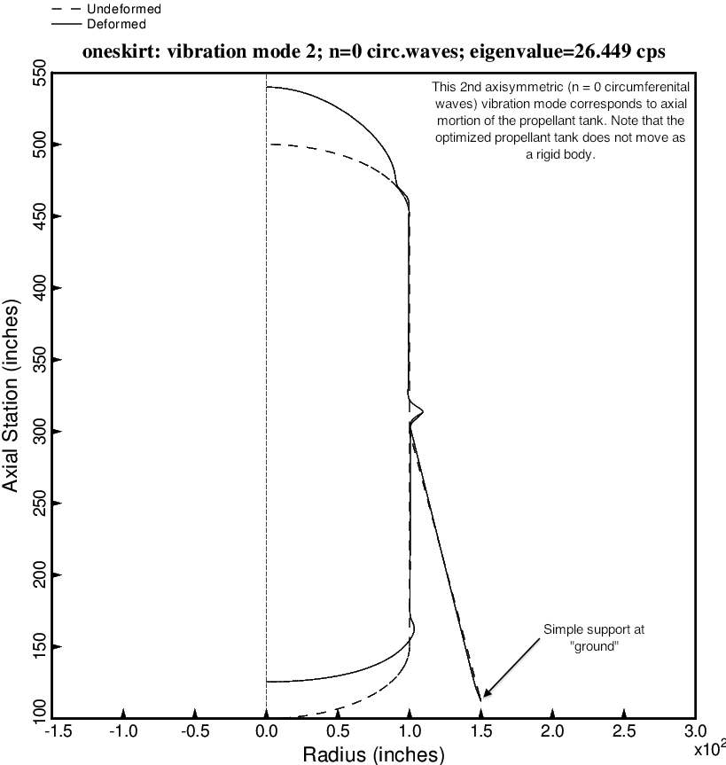

Fig. 4 (old) Axisymmetric axial vibration mode for the optimized tank/skirt system determined with use of the “regular” or “permanent” versions of bosdec (bosdec.tank2) and addbosor4 (addbosor4.regular).

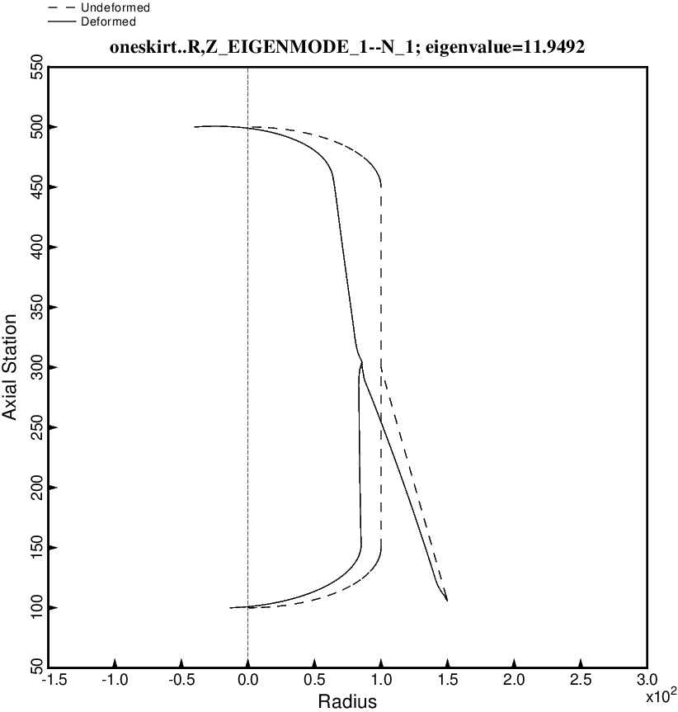

Fig. 5 (new) Lateral-pitching vibration mode No. 1 for the optimized tank/skirt system determined with use of the “regular” or “permanent” versions of bosdec (bosdec.tank2) and addbosor4 (addbosor4.regular).

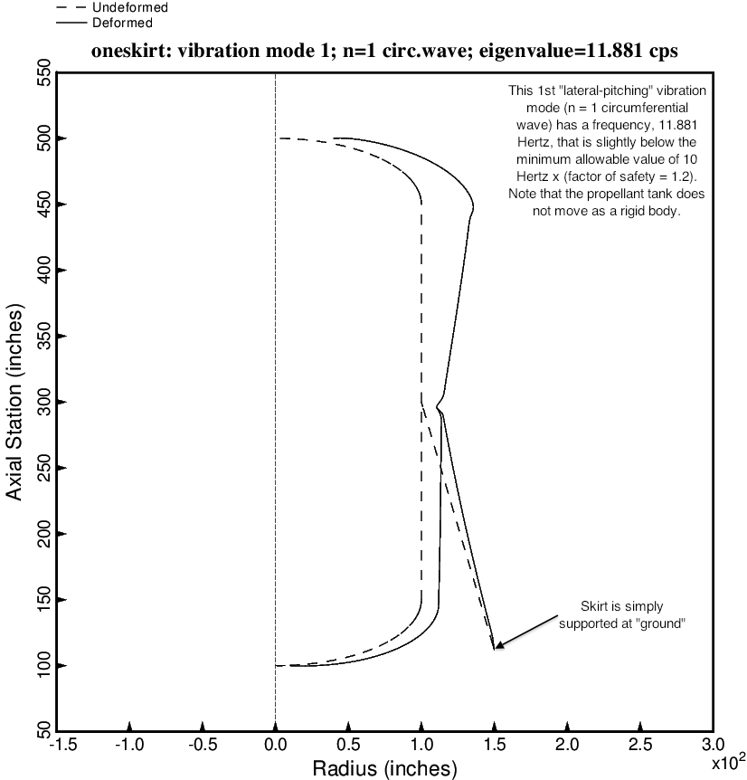

Fig. 5 (old) Lateral-pitching vibration mode No. 1 for the optimized tank/skirt system determined with use of the “regular” or “permanent” versions of bosdec (bosdec.tank2) and addbosor4 (addbosor4.regular).

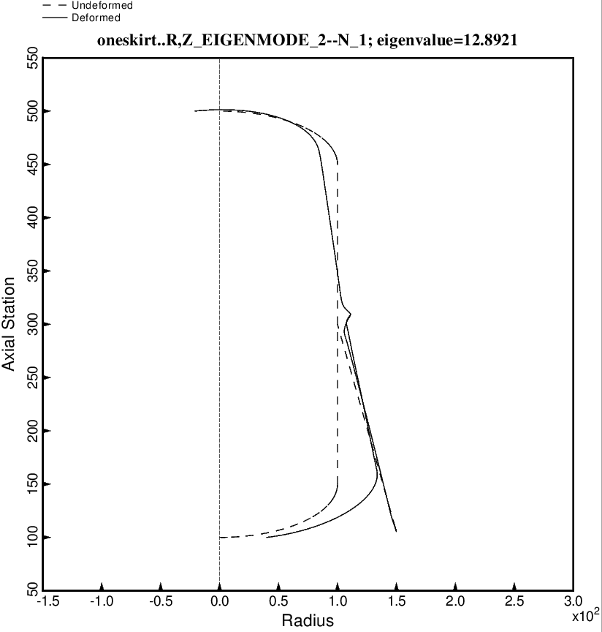

Fig. 6 (new) Lateral-pitching vibration mode No. 2 for the optimized tank/skirt system determined with use of the “regular” or “permanent” versions of bosdec (bosdec.tank2) and addbosor4 (addbosor4.regular).

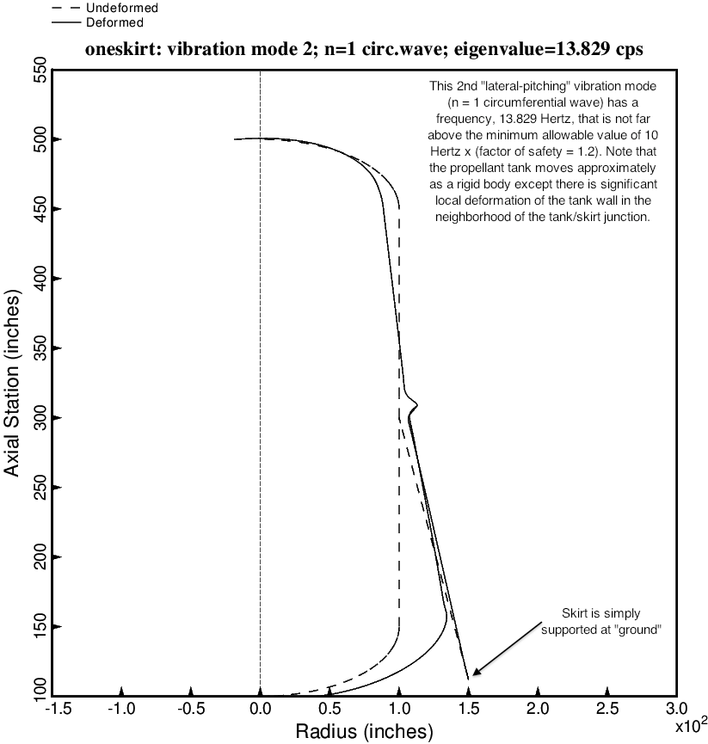

Fig. 6 (old) Lateral-pitching vibration mode No. 2 for the optimized tank/skirt system determined with use of the “regular” or “permanent” versions of bosdec (bosdec.tank2) and addbosor4 (addbosor4.regular).

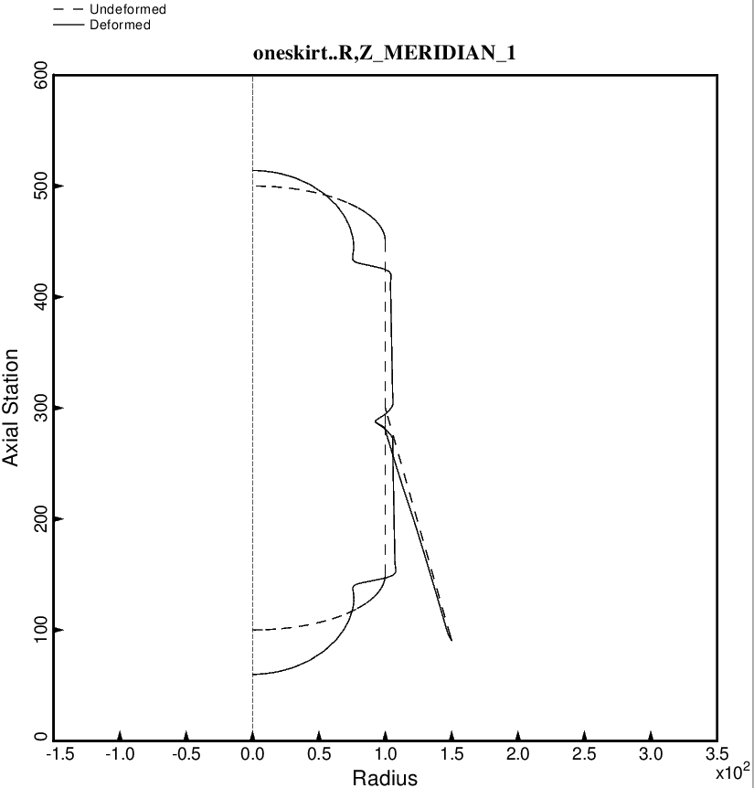

Fig. 7 (new) Axisymmetric prebuckling deformations of the optimized tank/skirt system determined with use of the “temporary” versions of bosdec (bosdec.tank2.density.var) and addbosor4 (addbosor4.tank2.density.var). The g-loading is AXIAL.

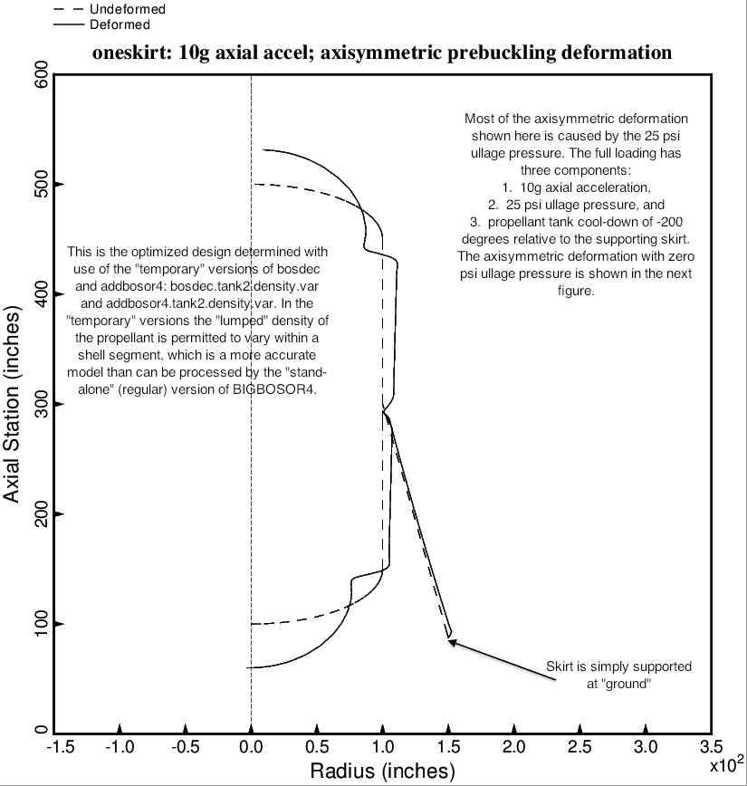

Fig. 7 (old) Axisymmetric prebuckling deformations of the optimized tank/skirt system determined with use of the “temporary” versions of bosdec (bosdec.tank2.density.var) and addbosor4 (addbosor4.tank2.density.var). The g-loading is AXIAL.

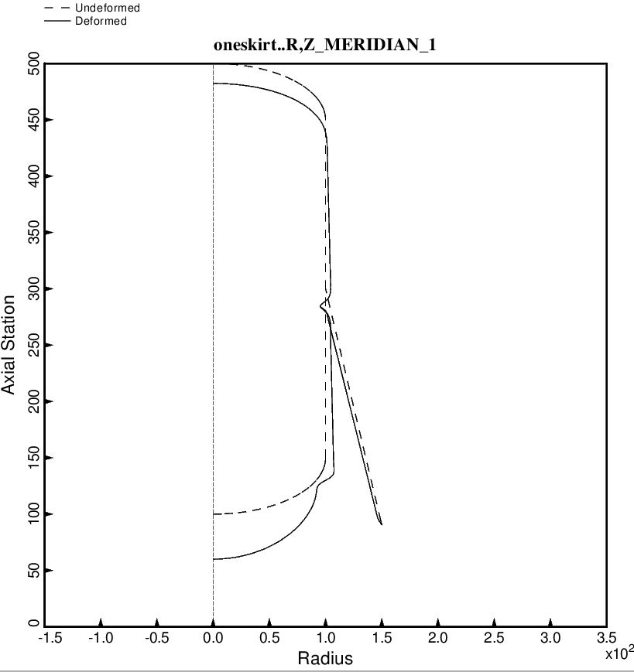

Fig. 8 (new) Axisymmetric prebuckling deformations of the optimized tank/skirt system determined with use of the “temporary” versions of bosdec (bosdec.tank2.density.var) and addbosor4 (addbosor4.tank2.density.var). In this case the ullage pressure and the tank cool-down temperature are both zero. Compare with the previous two figures. The g-loading is AXIAL.

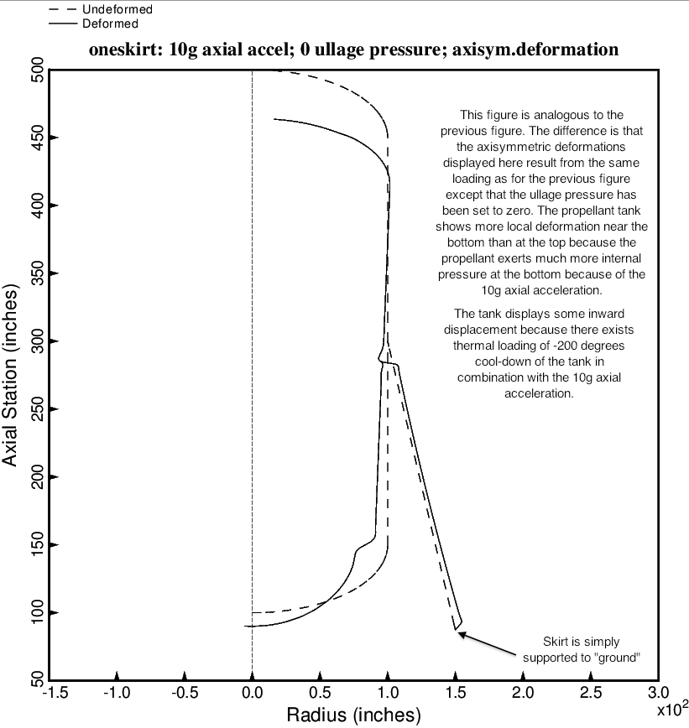

Fig. 8 (old) Axisymmetric prebuckling deformations of the optimized tank/skirt system determined with use of the “temporary” versions of bosdec (bosdec.tank2.density.var) and addbosor4 (addbosor4.tank2.density.var). In this case the ullage pressure is zero. Compare with the previous figure. The g-loading is AXIAL.

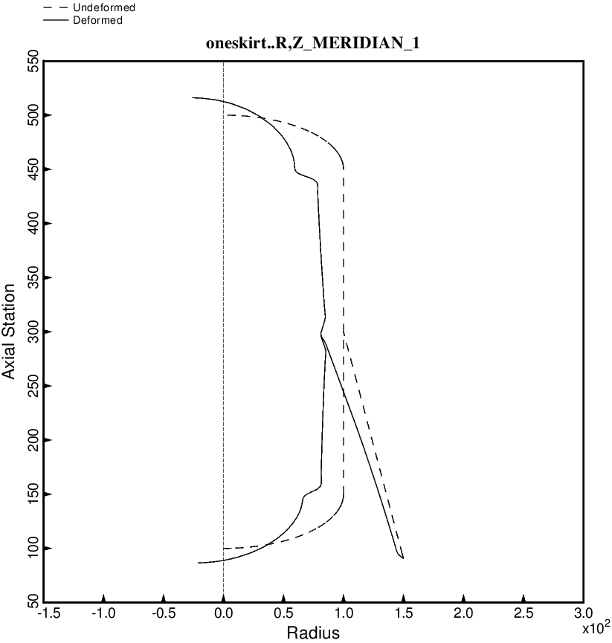

Fig. 9 (new) Nonsymmetric prebuckling deformations of the optimized tank/skirt system determined with use of the “temporary” versions of bosdec (bosdec.tank2.density.var) and addbosor4 (addbosor4.tank2.density.var).The g-loading is LATERAL.

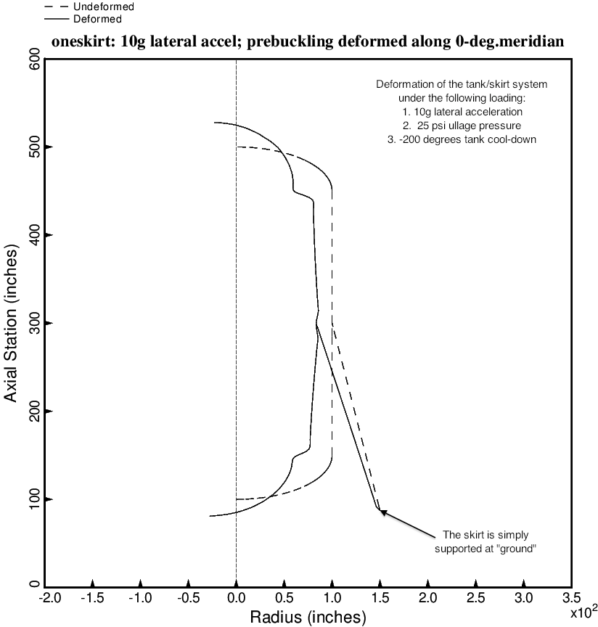

Fig. 9 (old) Nonsymmetric prebuckling deformations of the optimized tank/skirt system determined with use of the “temporary” versions of bosdec (bosdec.tank2.density.var) and addbosor4 (addbosor4.tank2.density.var).The g-loading is LATERAL.

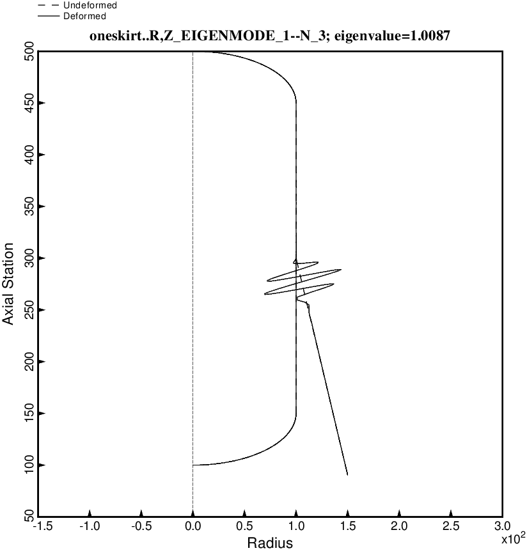

Fig. 10 (new) Nonsymmetric buckling modal deformations of the optimized tank/skirt system determined with use of the “temporary” versions of bosdec (bosdec.tank2.density.var) and addbosor4 (addbosor4.tank2.density.var). The inertial loading is 10g AXIAL acceleration. For n = 3 circumferential waves the lowest buckling load factor corresponds to short-axial-wavelength buckling of the skirt.

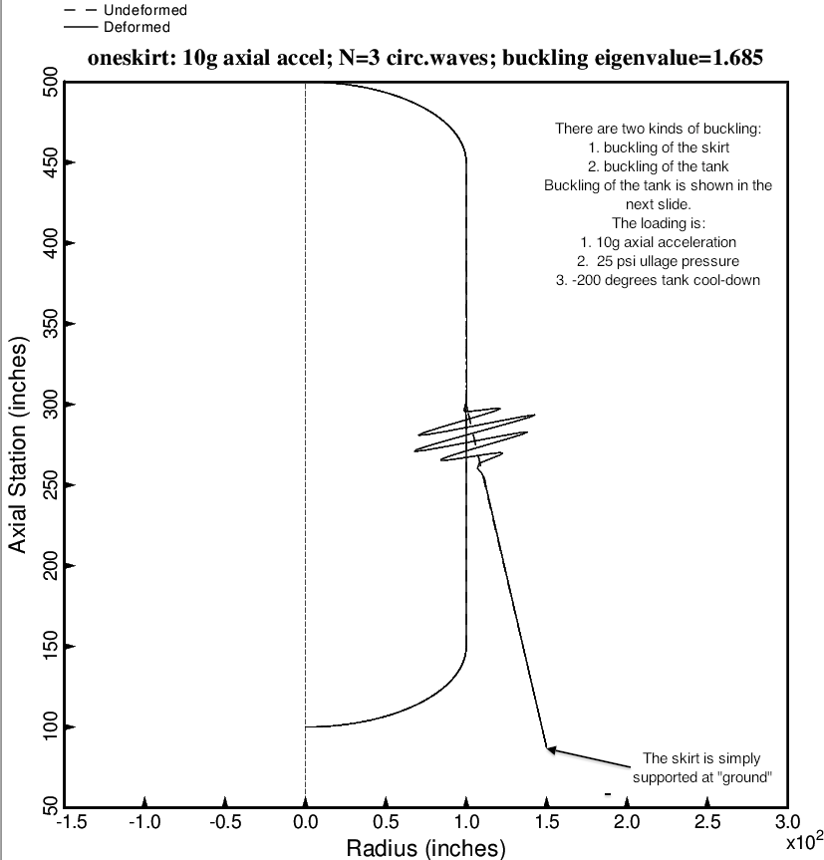

Fig. 10 (old) Nonsymmetric buckling modal deformations of the optimized tank/skirt system determined with use of the “temporary” versions of bosdec (bosdec.tank2.density.var) and addbosor4 (addbosor4.tank2.density.var). The inertial loading is 10g AXIAL acceleration. For n = 3 circumferential waves the lowest buckling load factor corresponds to short-axial-wavelength buckling of the skirt.

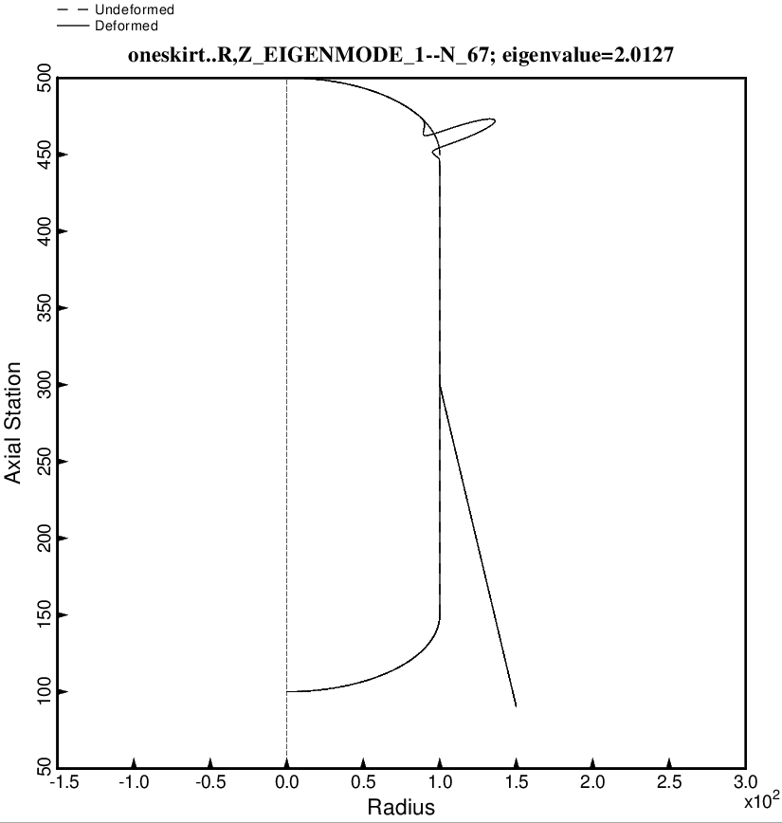

Fig. 11 (new) Nonsymmetric buckling modal deformations of the optimized tank/skirt system determined with use of the “temporary” versions of bosdec (bosdec.tank2.density.var) and addbosor4 (addbosor4.tank2.density.var). The inertial loading is 10g AXIAL acceleration. For n = 67 circumferential waves the lowest buckling load factor corresponds to short-circumferential-wavelength buckling of the upper 2:1 ellipsoidal dome of the propellant tank under internal pressure.

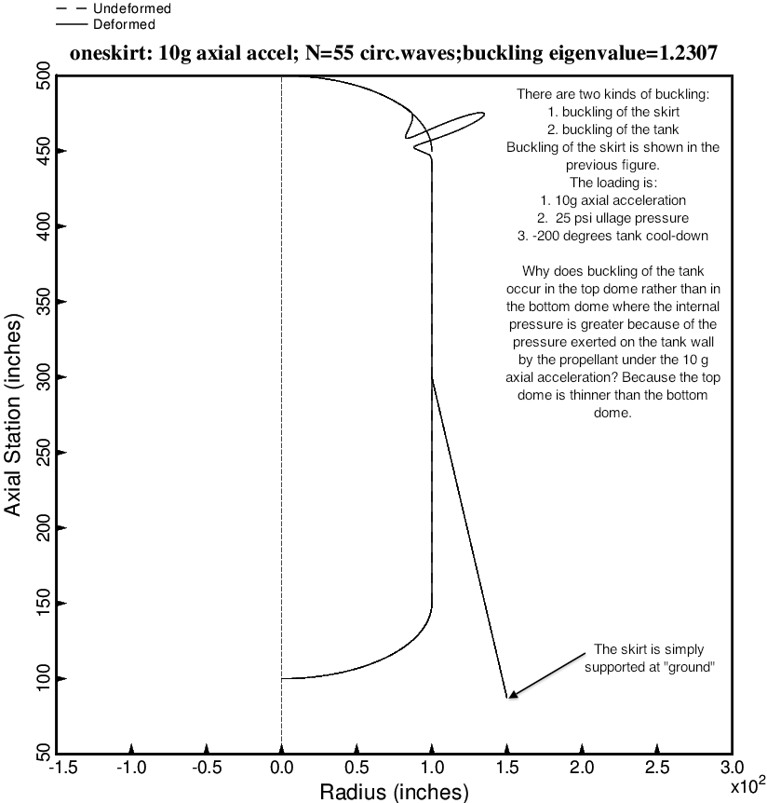

Fig. 11 (old) Nonsymmetric buckling modal deformations of the optimized tank/skirt system determined with use of the “temporary” versions of bosdec (bosdec.tank2.density.var) and addbosor4 (addbosor4.tank2.density.var). The inertial loading is 10g AXIAL acceleration. For n = 55 circumferential waves the lowest buckling load factor corresponds to short-circumferential-wavelength buckling of the upper 2:1 ellipsoidal dome of the propellant tank under internal pressure.

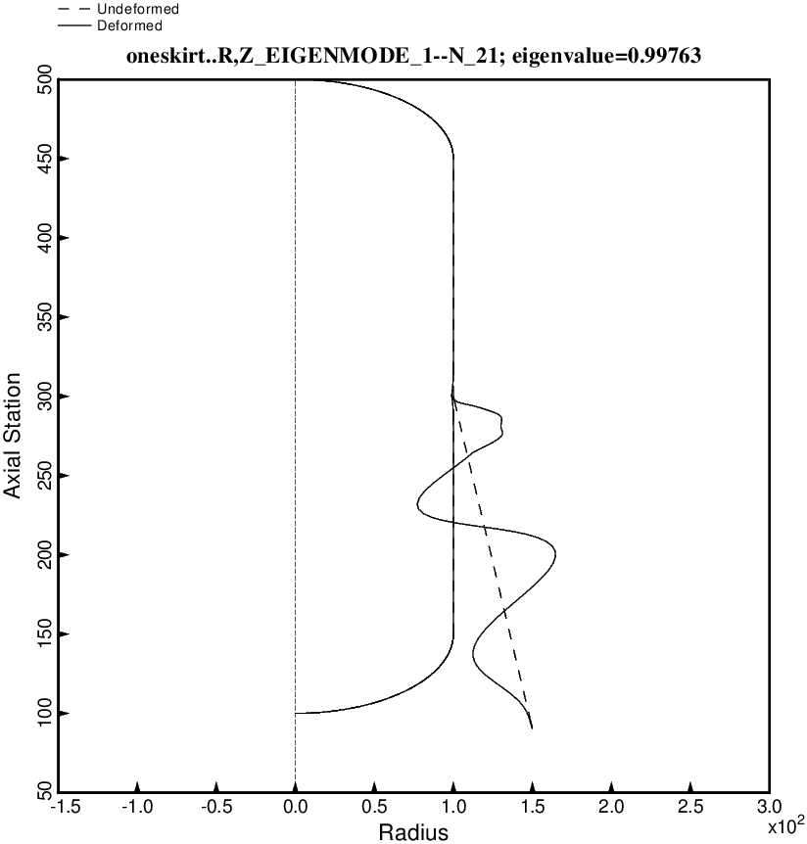

Fig. 12 (new) Nonsymmetric buckling modal deformations of the optimized tank/skirt system determined with use of the “temporary” versions of bosdec (bosdec.tank2.density.var) and addbosor4 (addbosor4.tank2.density.var). The inertial loading is 10g LATERAL acceleration. For n = 21 circumferential waves the lowest buckling load factor corresponds to long-axial-wavelength buckling of the skirt.

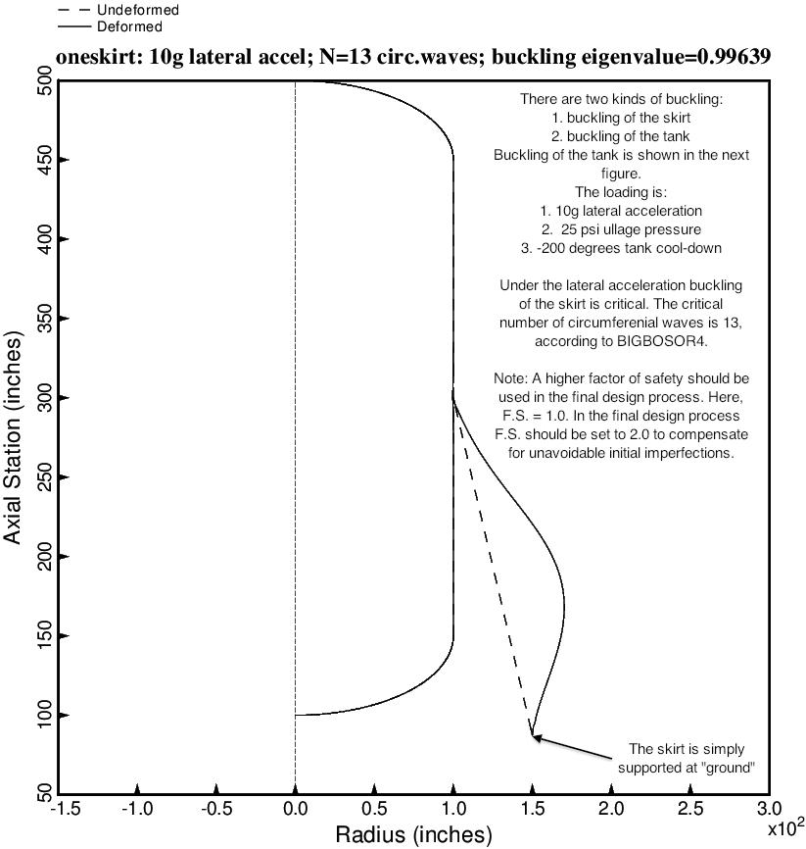

Fig. 12 (old) Nonsymmetric buckling modal deformations of the optimized tank/skirt system determined with use of the “temporary” versions of bosdec (bosdec.tank2.density.var) and addbosor4 (addbosor4.tank2.density.var). The inertial loading is 10g LATERAL acceleration. For n = 13 circumferential waves the lowest buckling load factor corresponds to long-axial-wavelength buckling of the skirt.

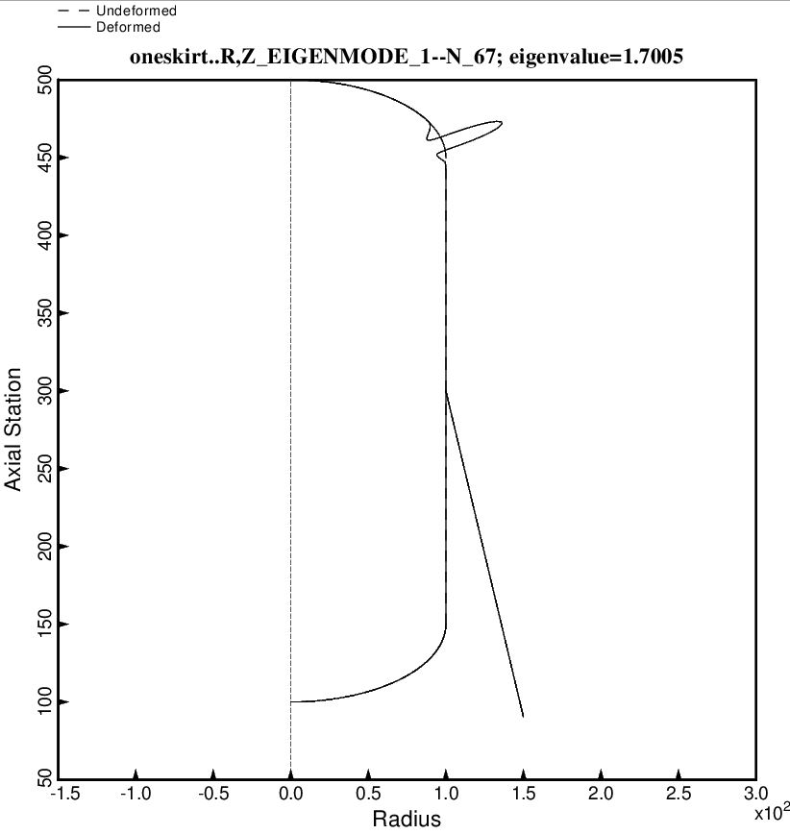

Fig. 13 (new) Nonsymmetric buckling modal deformations of the optimized tank/skirt system determined with use of the “temporary” versions of bosdec (bosdec.tank2.density.var) and addbosor4 (addbosor4.tank2.density.var). The inertial loading is 10g LATERAL acceleration. For n = 67 circumferential waves the lowest buckling load factor corresponds to short-circumferential buckling of the forward dome under internal pressure.

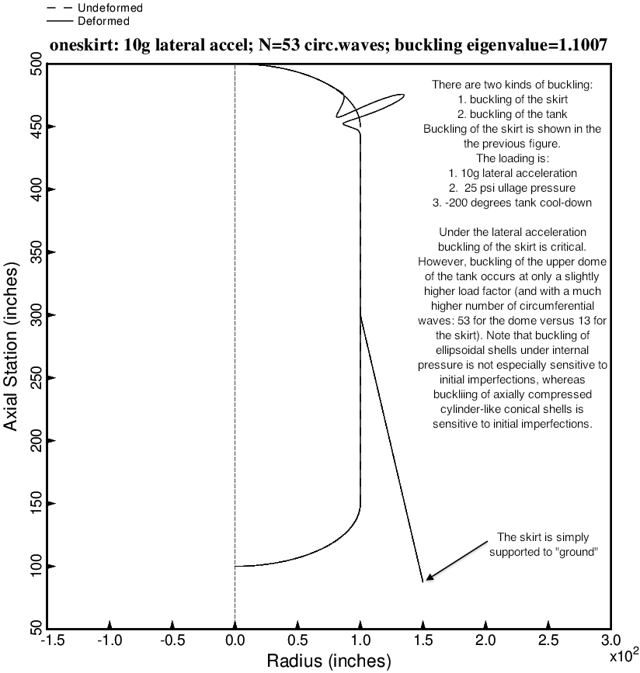

Fig. 13 (old) Nonsymmetric buckling modal deformations of the optimized tank/skirt system determined with use of the “temporary” versions of bosdec (bosdec.tank2.density.var) and addbosor4 (addbosor4.tank2.density.var). The inertial loading is 10g LATERAL acceleration. For n = 53 circumferential waves the lowest buckling load factor corresponds to short-circumferential buckling of the forward dome under internal pressure.

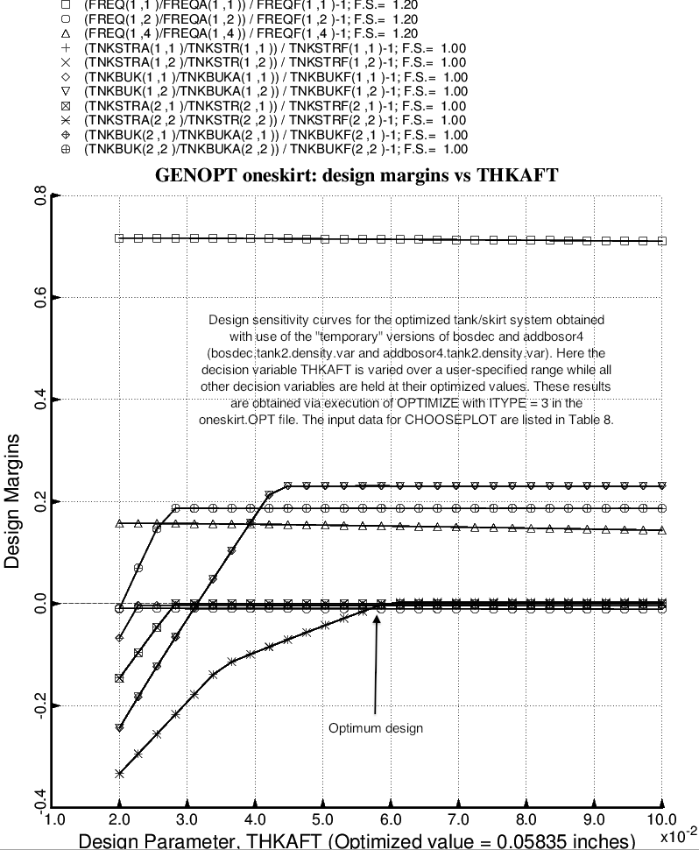

Fig. 14 (old) Design sensitivity with respect to the decision variable, THKAFT, of the optimized tank/skirt system determined with use of the “temporary” versions of bosdec (bosdec.tank2.density.var) and addbosor4 (addbosor4.tank2.density.var). NOTE: This and the next several figures were generated with the old optimum design obtained before certain corrections were made to the “tank2” software: behavior.tank2, bosdec.tank2 and bosdec.tank2.density.var. Please think of these figures only as a demonstration of the capability of GENOPT/BIGBOSOR4 to perform design sensitivity analyses of the sort shown here.

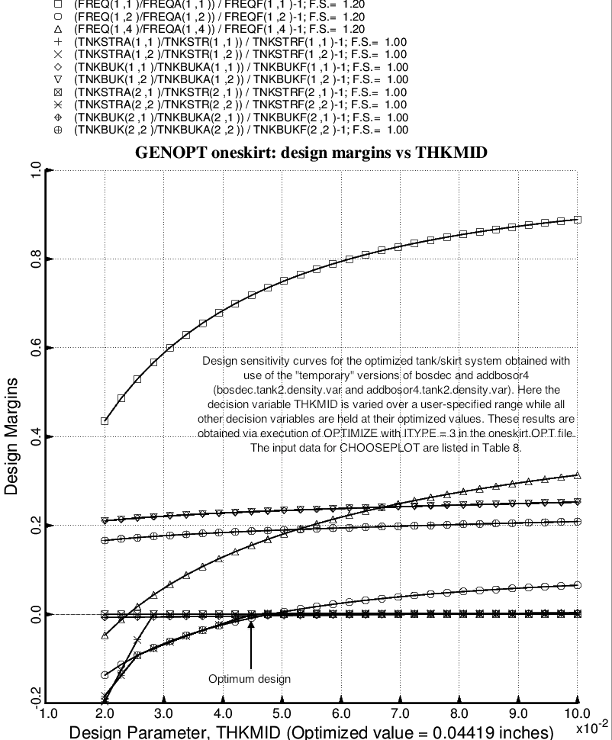

Fig. 15 (old) Design sensitivity with respect to the decision variable, THKMID, of the optimized tank/skirt system determined with use of the “temporary” versions of bosdec (bosdec.tank2.density.var) and addbosor4 (addbosor4.tank2.density.var). NOTE: This and the next several figures were generated with the old optimum design obtained before certain corrections were made to the “tank2” software: behavior.tank2, bosdec.tank2 and bosdec.tank2.density.var. Please think of these figures only as a demonstration of the capability of GENOPT/BIGBOSOR4 to perform design sensitivity analyses of the sort shown here.

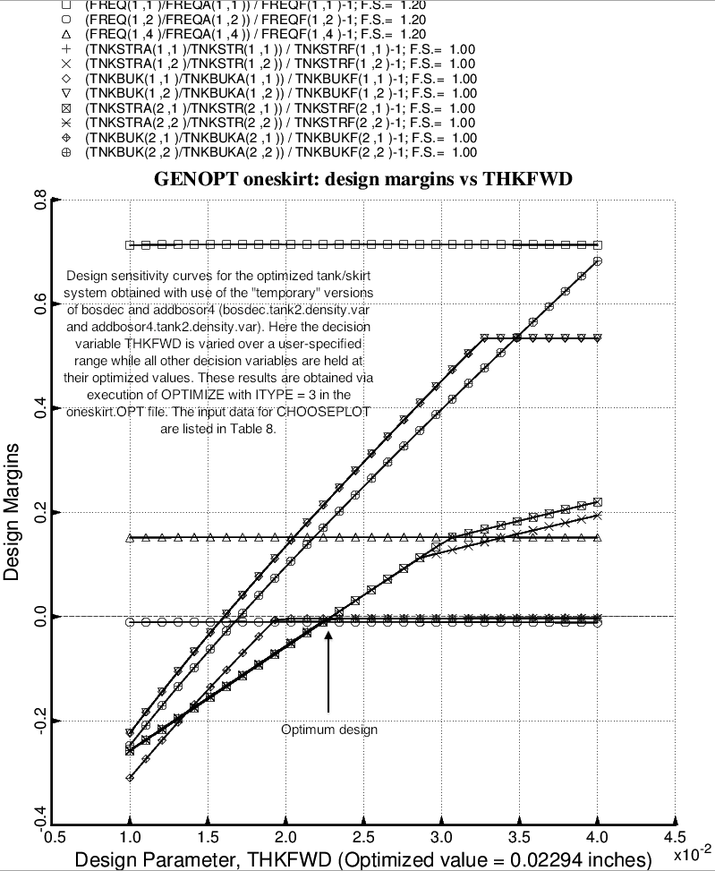

Fig. 16 (old) Design sensitivity with respect to the decision variable, THKFWD, of the optimized tank/skirt system determined with use of the “temporary” versions of bosdec (bosdec.tank2.density.var) and addbosor4 (addbosor4.tank2.density.var). NOTE: This and the next several figures were generated with the old optimum design obtained before certain corrections were made to the “tank2” software: behavior.tank2, bosdec.tank2 and bosdec.tank2.density.var. Please think of these figures only as a demonstration of the capability of GENOPT/BIGBOSOR4 to perform design sensitivity analyses of the sort shown here.

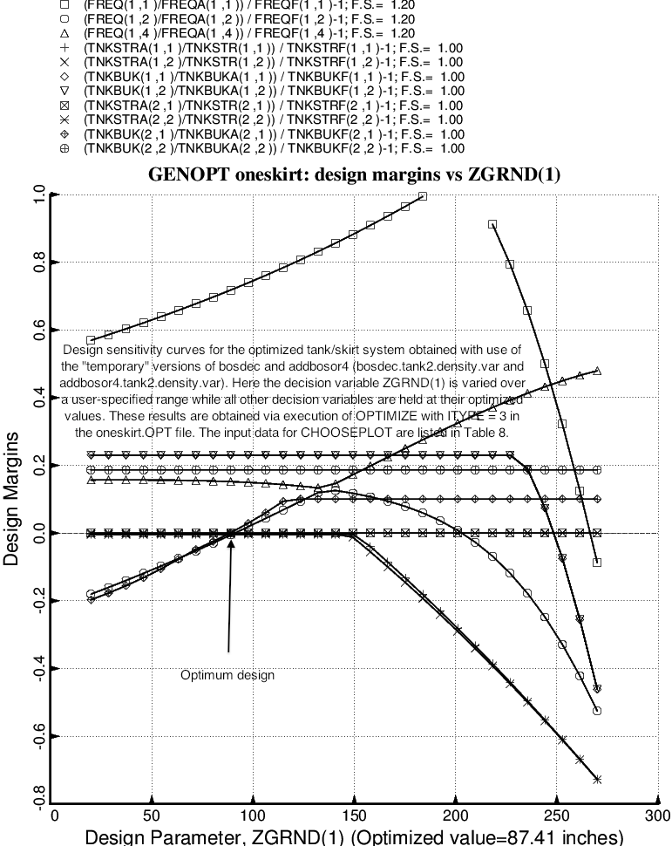

Fig. 17 (old) Design sensitivity with respect to the decision variable, ZGRND(1), of the optimized tank/skirt system determined with use of the “temporary” versions of bosdec (bosdec.tank2.density.var) and addbosor4 (addbosor4.tank2.density.var). NOTE: This and the next several figures were generated with the old optimum design obtained before certain corrections were made to the “tank2” software: behavior.tank2, bosdec.tank2 and bosdec.tank2.density.var. Please think of these figures only as a demonstration of the capability of GENOPT/BIGBOSOR4 to perform design sensitivity analyses of the sort shown here.

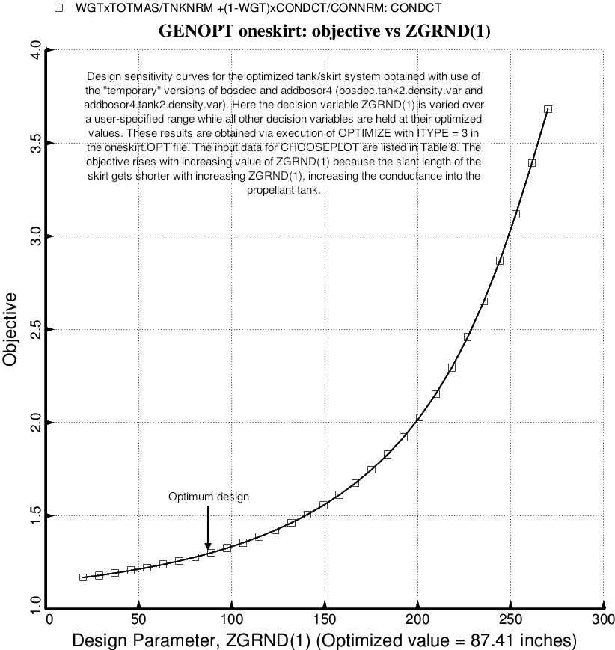

Fig. 18 (old) Design sensitivity with respect to the decision variable, ZGRND(1), of the objective of the optimized tank/skirt system determined with use of the “temporary” versions of bosdec (bosdec.tank2.density.var) and addbosor4 (addbosor4.tank2.density.var). NOTE: This and the next several figures were generated with the old optimum design obtained before certain corrections were made to the “tank2” software: behavior.tank2, bosdec.tank2 and bosdec.tank2.density.var. Please think of these figures only as a demonstration of the capability of GENOPT/BIGBOSOR4 to perform design sensitivity analyses of the sort shown here.

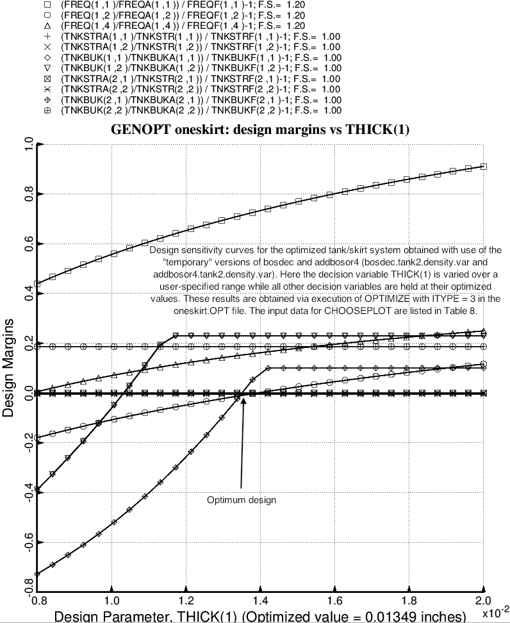

Fig. 19 (old) Design sensitivity with respect to the decision variable, THICK(1), of the optimized tank/skirt system determined with use of the “temporary” versions of bosdec (bosdec.tank2.density.var) and addbosor4 (addbosor4.tank2.density.var). NOTE: This and the next two figures were generated with the old optimum design obtained before certain corrections were made to the “tank2” software: behavior.tank2, bosdec.tank2 and bosdec.tank2.density.var. Please think of these figures only as a demonstration of the capability of GENOPT/BIGBOSOR4 to perform design sensitivity analyses of the sort shown here.

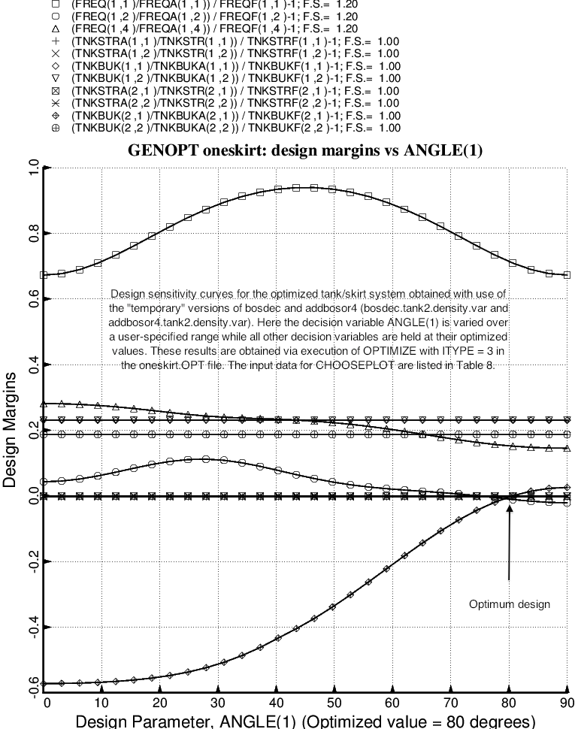

Fig. 20 (old) Design sensitivity with respect to the decision variable, ANGLE(1) of the optimized tank/skirt system determined with use of the “temporary” versions of bosdec (bosdec.tank2.density.var) and addbosor4 (addbosor4.tank2.density.var). NOTE: This and the next figure were generated with the old optimum design obtained before certain corrections were made to the “tank2” software: behavior.tank2, bosdec.tank2 and bosdec.tank2.density.var. Please think of these figures only as a demonstration of the capability of GENOPT/BIGBOSOR4 to perform design sensitivity analyses of the sort shown here.

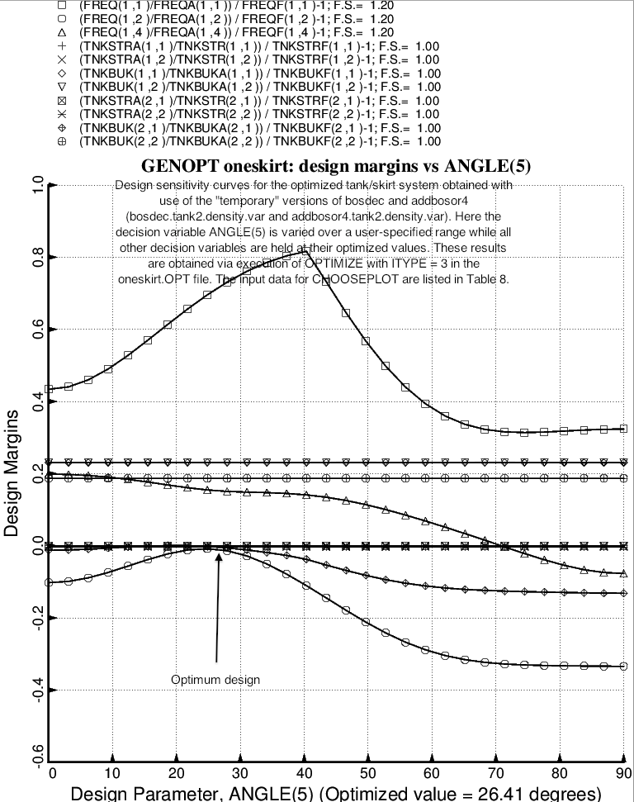

Fig. 21 (old) Design sensitivity with respect to the decision variable, ANGLE(5), of the optimized tank/skirt system determined with use of the “temporary” versions of bosdec (bosdec.tank2.density.var) and addbosor4 (addbosor4.tank2.density.var). NOTE: This and the previous several figures were generated with the old optimum design obtained before certain corrections were made to the “tank2” software: behavior.tank2, bosdec.tank2 and bosdec.tank2.density.var. Please think of these figures only as a demonstration of the capability of GENOPT/BIGBOSOR4 to perform design sensitivity analyses of the sort shown here.

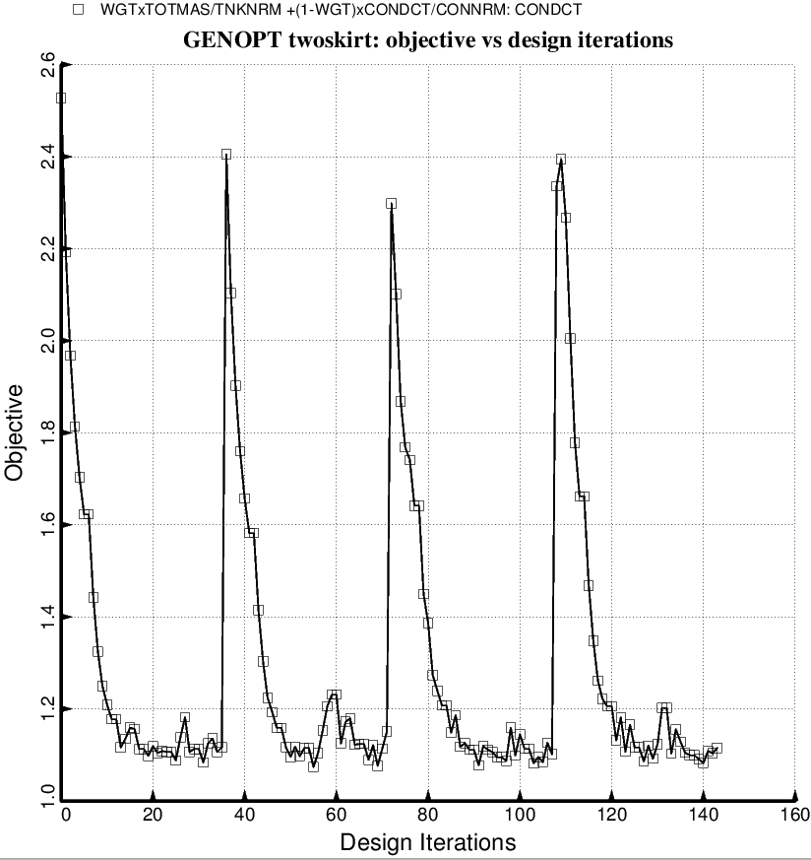

Fig. 22a (new) Evolution of the objective during a partial execution of SUPEROPT for the specific case, “twoskirt” obtained with the use of the “temporary” versions of bosdec (bosdec.tank2.density.var) and addbosor4 (addbosor4.tank2.density.var). The “twoskirt” input variables are listed in twoskirt.BEG and the decision variables are listed in twoskirt.DEC. This and the next several slides pertain to the specific case called “twoskirt”. In order to treat “twoskirt” the GENOPT software had to be modified to permit more decision variable candidates.

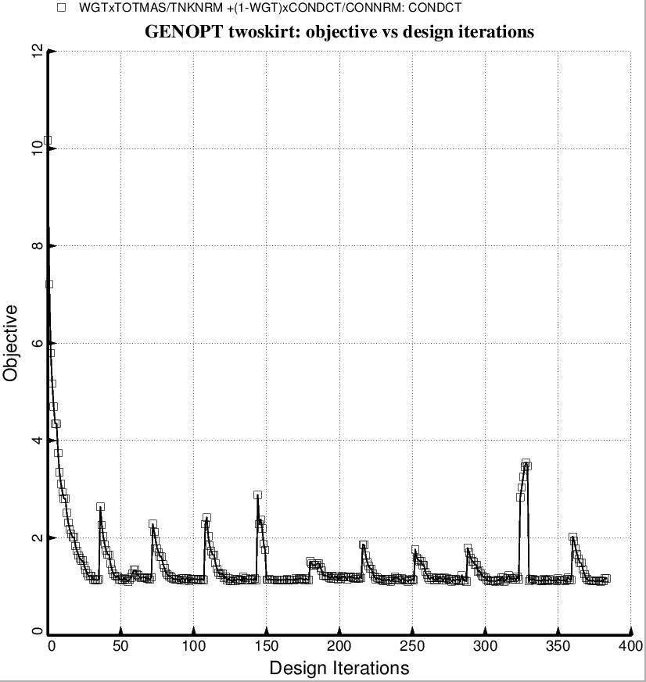

Fig. 22b (new) Evolution of the objective during a partial execution of SUPEROPT for the specific case, “twoskirt” obtained with the use of the “permanent” versions of bosdec (bosdec.tank2) and addbosor4 (addbosor4.regular). The “twoskirt” input variables are listed in twoskirt.BEG and the decision variables are listed in twoskirt.DEC. This and the next several slides pertain to the specific case called “twoskirt”. In order to treat “twoskirt” the GENOPT software had to be modified to permit more decision variable candidates.

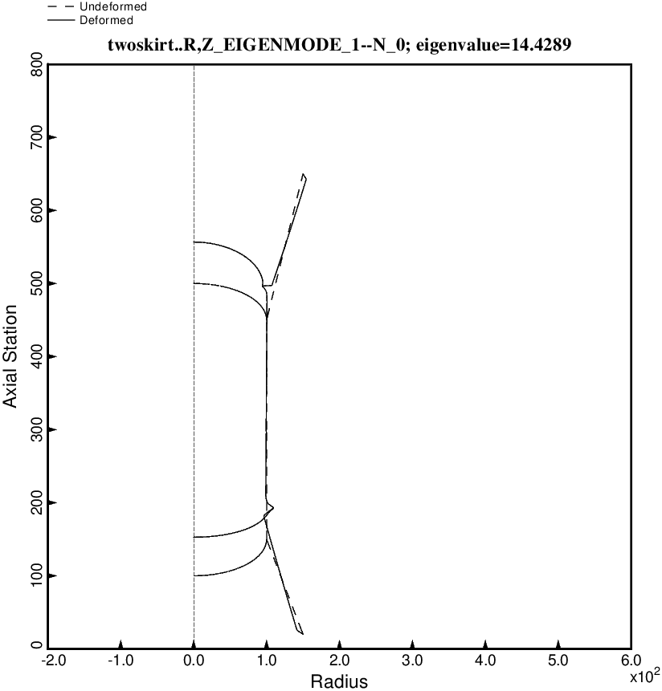

Fig. 23 (new) Axisymmetric axial vibration mode for the optimized tank/skirt system determined with use of the “regular” or “permanent” versions of bosdec (bosdec.tank2) and addbosor4 (addbosor4.regular).

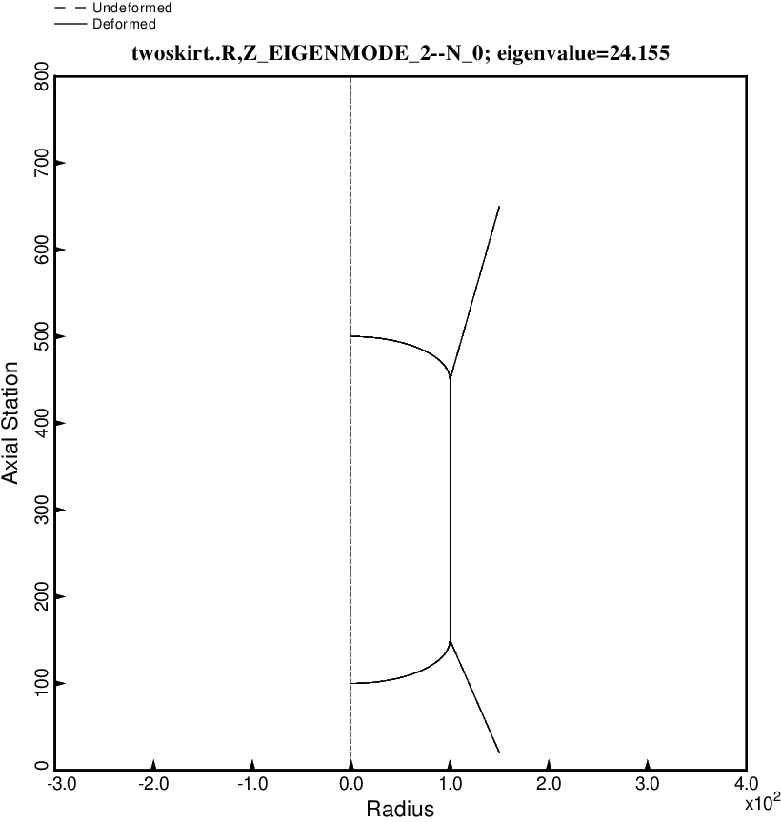

Fig. 24 (new) Axisymmetric rolling vibration mode for the optimized tank/skirt system determined with use of the “regular” or “permanent” versions of bosdec (bosdec.tank2) and addbosor4 (addbosor4.regular).

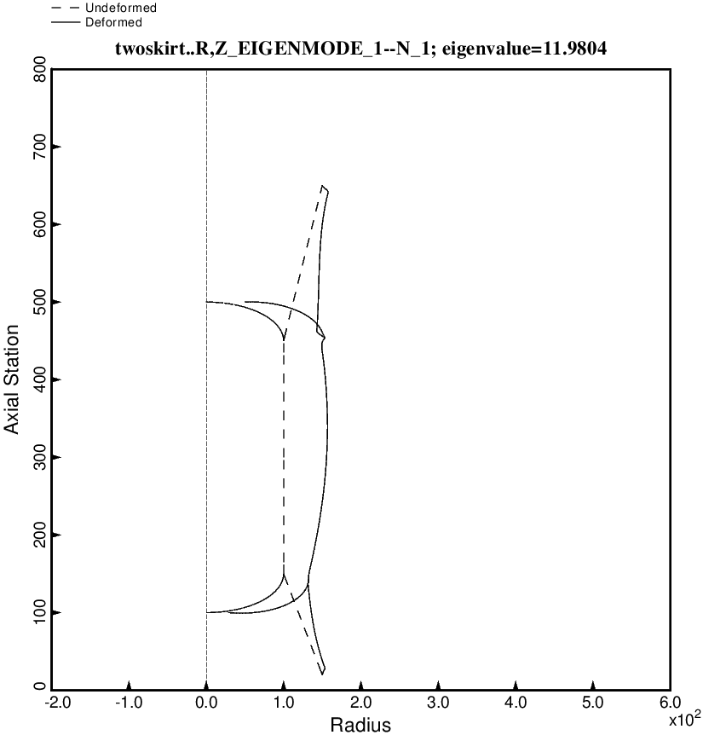

Fig. 25 (new) Lateral-pitching vibration mode No. 1 for the optimized tank/skirt system determined with use of the “regular” or “permanent” versions of bosdec (bosdec.tank2) and addbosor4 (addbosor4.regular).

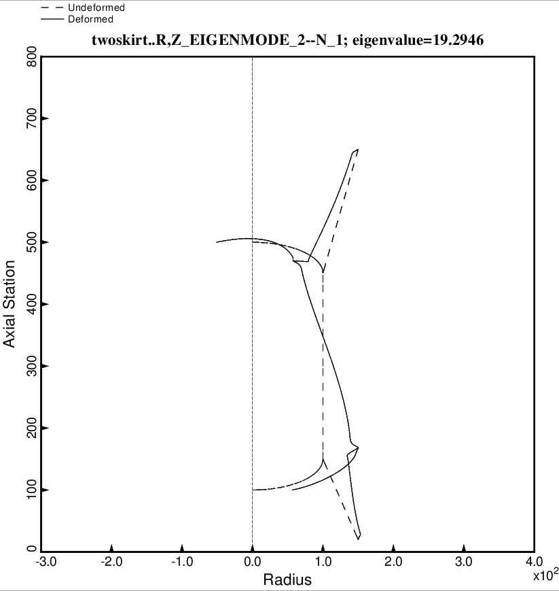

Fig. 26 (new) Lateral-pitching vibration mode No. 2 for the optimized tank/skirt system determined with use of the “regular” or “permanent” versions of bosdec (bosdec.tank2) and addbosor4 (addbosor4.regular).

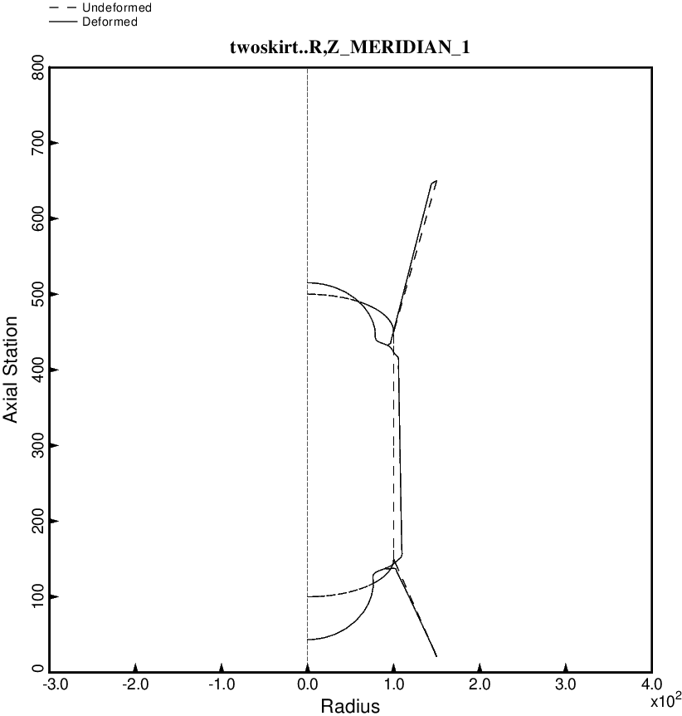

Fig. 27 (new) Axisymmetric prebuckling deformations of the optimized tank/skirt system determined with use of the “temporary” versions of bosdec (bosdec.tank2.density.var) and addbosor4 (addbosor4.tank2.density.var). The g-loading is AXIAL.

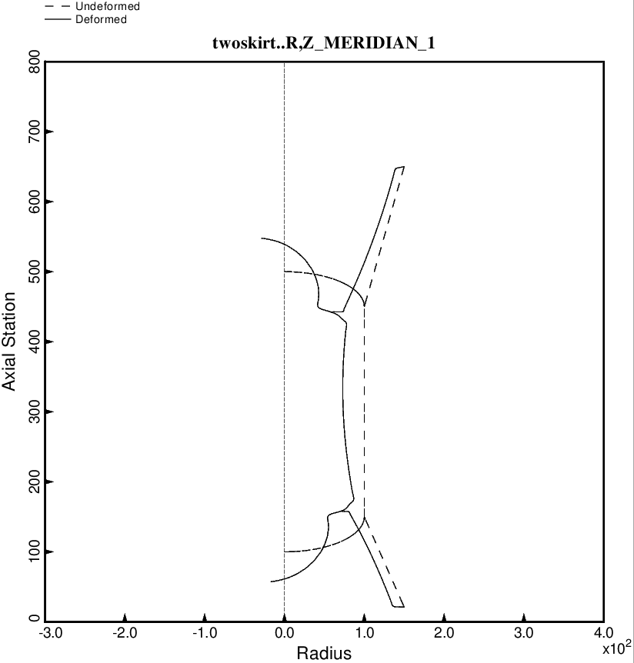

Fig. 28 (new) Nonsymmetric prebuckling deformations of the optimized tank/skirt system determined with use of the “temporary” versions of bosdec (bosdec.tank2.density.var) and addbosor4 (addbosor4.tank2.density.var).The g-loading is LATERAL.

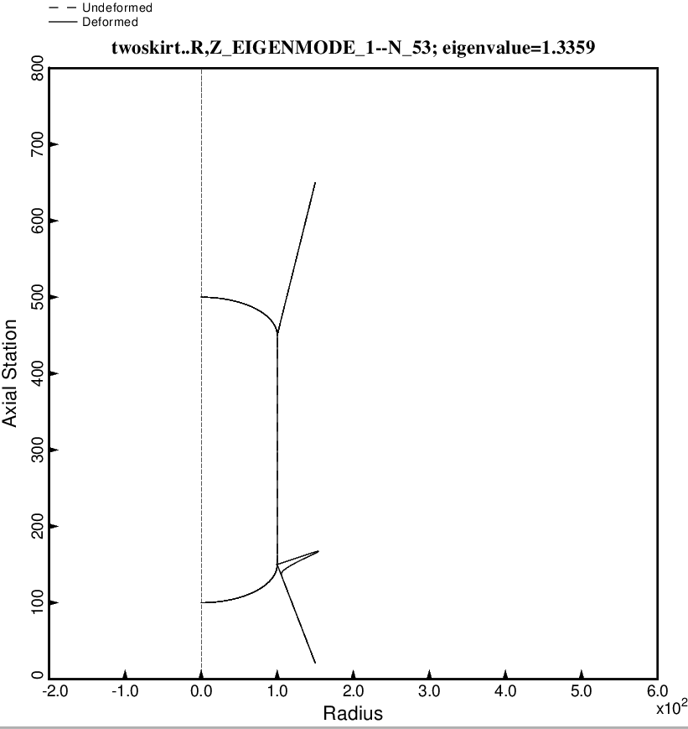

Fig. 29 (new) Nonsymmetric buckling modal deformations of the optimized tank/skirt system determined with use of the “temporary” versions of bosdec (bosdec.tank2.density.var) and addbosor4 (addbosor4.tank2.density.var). The inertial loading is 10g AXIAL acceleration. For n = 53 circumferential waves the lowest buckling load factor corresponds to short-axial-wavelength buckling of the forward part of the aft skirt.

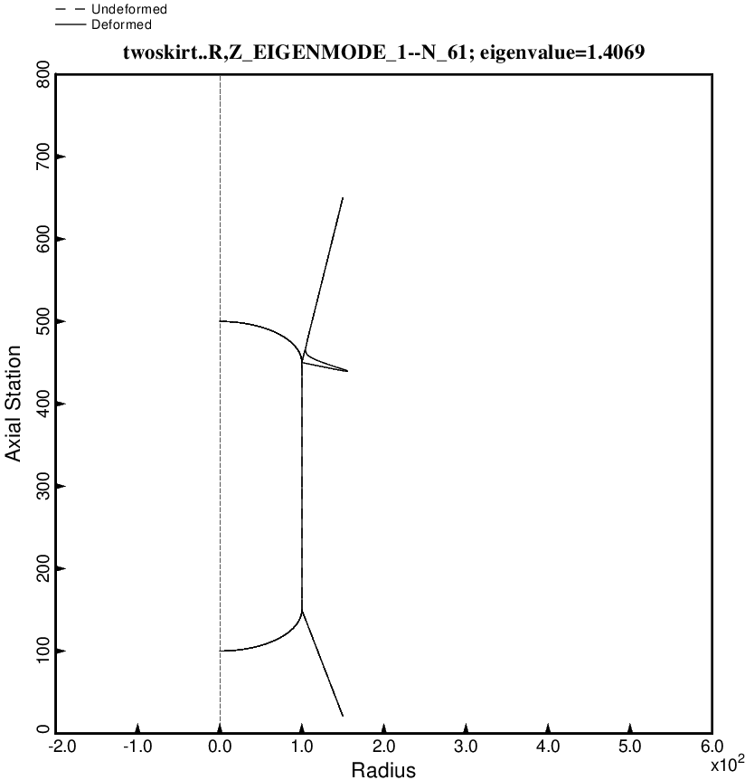

Fig. 30 (new) Nonsymmetric buckling modal deformations of the optimized tank/skirt system determined with use of the “temporary” versions of bosdec (bosdec.tank2.density.var) and addbosor4 (addbosor4.tank2.density.var). The inertial loading is 10g LATERAL acceleration. For n = 61 circumferential waves the lowest buckling load factor corresponds to short-axial-wavelength buckling of the aft part of the forward skirt.

