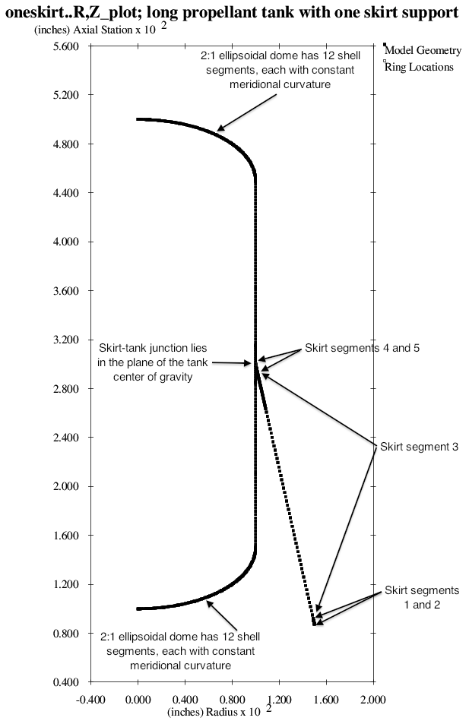

Fig. 1 Optimized discretized tank/skirt system obtained with the use of the “temporary” versions of bosdec (bosdec.tank2.density.var) and addbosor4 (addbosor4.tank2.density.var). Predictions from this optimized configuration should be compared with predictions from STAGS. The configuration and GENOPT/BIGBOSOR4 predictions are listed in Table 6. The bottom end of the skirt is simply supported to “ground” (the rigid launch vehicle).

