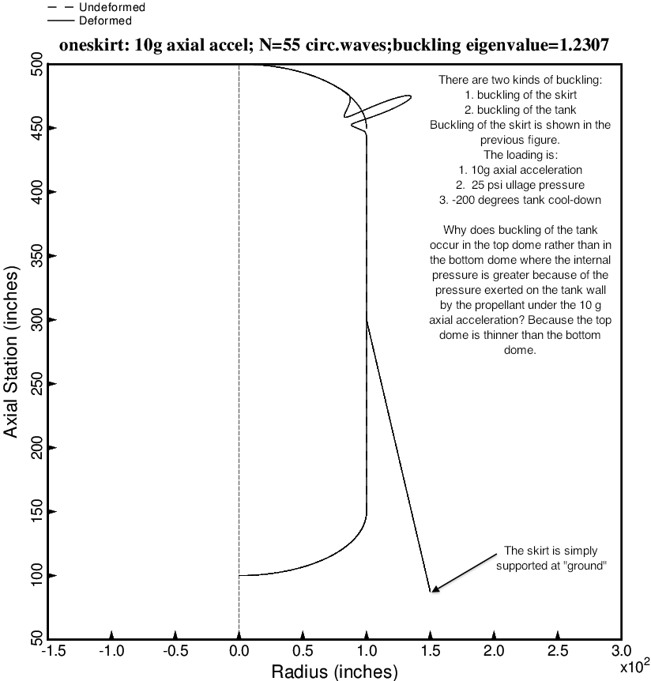

Fig. 11 (old) Nonsymmetric buckling modal deformations of the optimized tank/skirt system determined with use of the “temporary” versions of bosdec (bosdec.tank2.density.var) and addbosor4 (addbosor4.tank2.density.var). The inertial loading is 10g AXIAL acceleration. For n = 55 circumferential waves the lowest buckling load factor corresponds to short-circumferential-wavelength buckling of the upper 2:1 ellipsoidal dome of the propellant tank under internal pressure.

