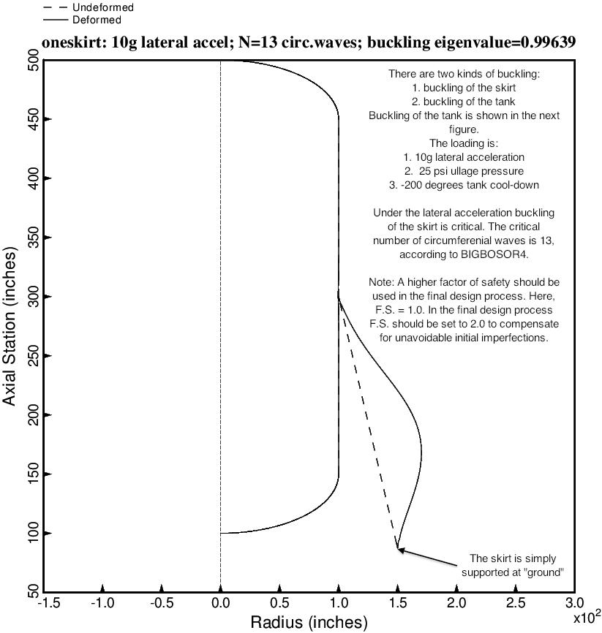

Fig. 12 (old) Nonsymmetric buckling modal deformations of the optimized tank/skirt system determined with use of the “temporary” versions of bosdec (bosdec.tank2.density.var) and addbosor4 (addbosor4.tank2.density.var). The inertial loading is 10g LATERAL acceleration. For n = 13 circumferential waves the lowest buckling load factor corresponds to long-axial-wavelength buckling of the skirt.

