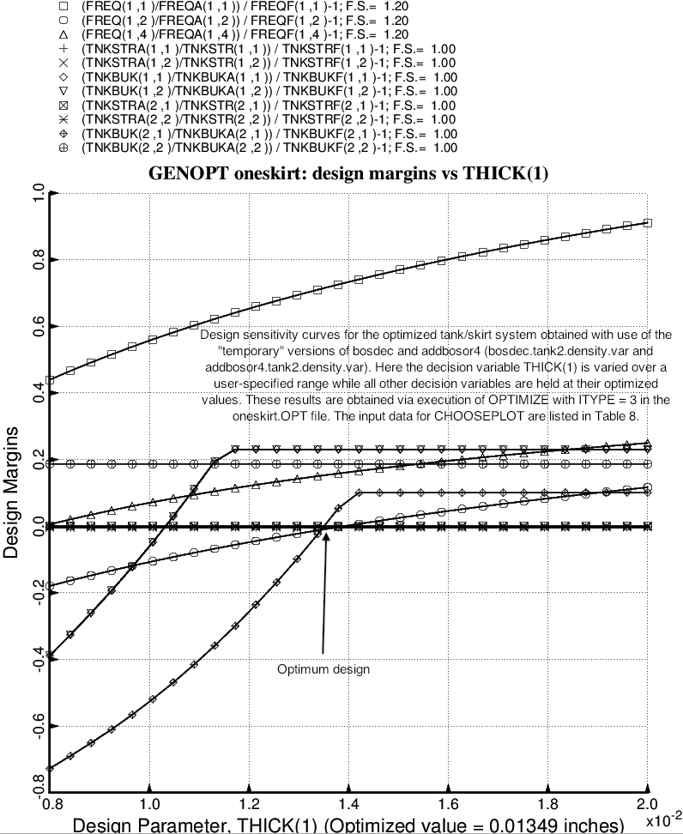

Fig. 19 (old) Design sensitivity with respect to the decision variable, THICK(1), of the optimized tank/skirt system determined with use of the “temporary” versions of bosdec (bosdec.tank2.density.var) and addbosor4 (addbosor4.tank2.density.var). NOTE: This and the next two figures were generated with the old optimum design obtained before certain corrections were made to the “tank2” software: behavior.tank2, bosdec.tank2 and bosdec.tank2.density.var. Please think of these figures only as a demonstration of the capability of GENOPT/BIGBOSOR4 to perform design sensitivity analyses of the sort shown here.

