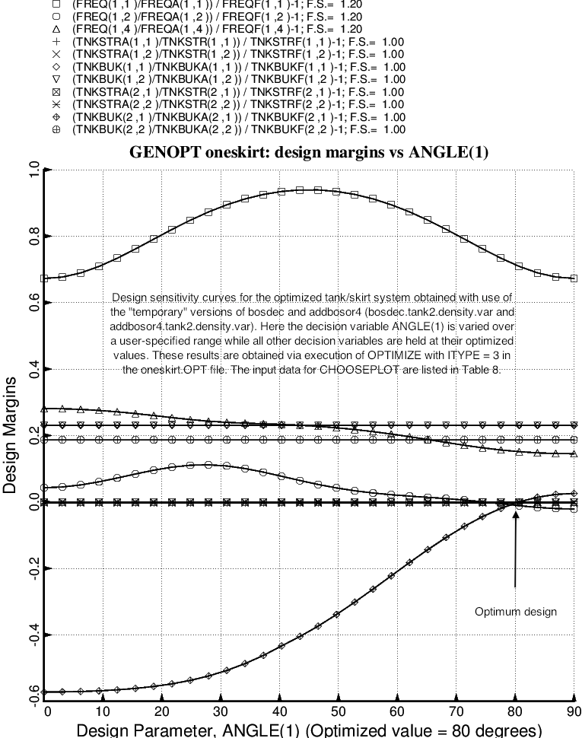

Fig. 20 (old) Design sensitivity with respect to the decision variable, ANGLE(1) of the optimized tank/skirt system determined with use of the “temporary” versions of bosdec (bosdec.tank2.density.var) and addbosor4 (addbosor4.tank2.density.var). NOTE: This and the next figure were generated with the old optimum design obtained before certain corrections were made to the “tank2” software: behavior.tank2, bosdec.tank2 and bosdec.tank2.density.var. Please think of these figures only as a demonstration of the capability of GENOPT/BIGBOSOR4 to perform design sensitivity analyses of the sort shown here.

